**AWS Documentation**

**Table of Contents**

1. AWS Basics (This separate document is in TCS asset)

2. AWS Elastic BeanStalk **(content to be added)**

-> how to deploy springboot app into AWS elastic beanstalk (jar file)

-> how to deploy react app into AWS elastic beanstalk

-> how to deploy full stack app into AWS elastic beanstalk

-> how to deploy containerised Java app into elastic beanstalk

-> AWS Elastic BeanStalk - CLI, Blue Green deployments and worker apps

-> AWS Elastic BeanStalk - creating Load Balanced auto scaled environments

3. Kubernetes Deployment Single Container

4. Multi Container App deployment

(A) Creating new environment in Elastic Bean Stalk

(B) EC2 Security Group

(C) Blue Green deployments

(D) Load Balancer configuration

(E) CloudWatch

5. Kubernetes in AWS (EKS in amazon)

6. AWS CodePipeline

**Multi Container Application deployment**

Get the Dockerrun.aws.json demo code from below url and customize this

<https://docs.aws.amazon.com/elasticbeanstalk/latest/dg/create_deploy_docker_v2config.html>

{

"AWSEBDockerrunVersion": 2,

"containerDefinitions": [

{

"name": "mysql",

"image": "mysql:5.7",

"environment": [

{

"name": "MYSQL_ROOT_PASSWORD",

"value": "dummypassword"

},

{

"name": "MYSQL_USER",

"value": "todos-user"

},

{

"name": "MYSQL_PASSWORD",

"value": "dummytodos"

},

{

"name": "MYSQL_DATABASE",

"value": "todos"

}

],

"essential": true,

"memory": 256,

"portMappings": [

{

"hostPort": 3306,

"containerPort": 3306

}

]

},

{

"name": "todo-rest-api",

"image": "in28min/todo-rest-api-mysql:1.0.0.RELEASE",

"essential": true,

"memory": 256,

"portMappings": [

{

"hostPort": 5000,

"containerPort": 5000

}

],

"links": [

"mysql"

]

}

]

}

**Creating new environment in Elastic Bean Stalk**

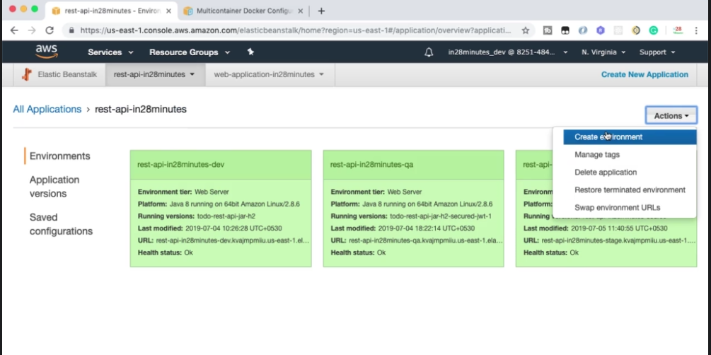

Go to Elastic Bean Stalk Environment-> Action-> Create Environment-> Select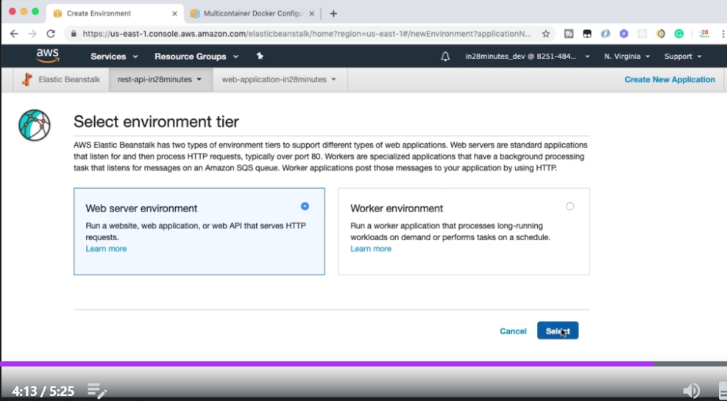

Select Environment name

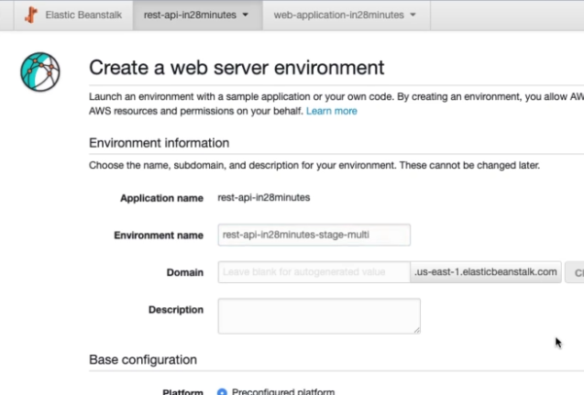

Keep rest as it is except choose platform as multi container docker

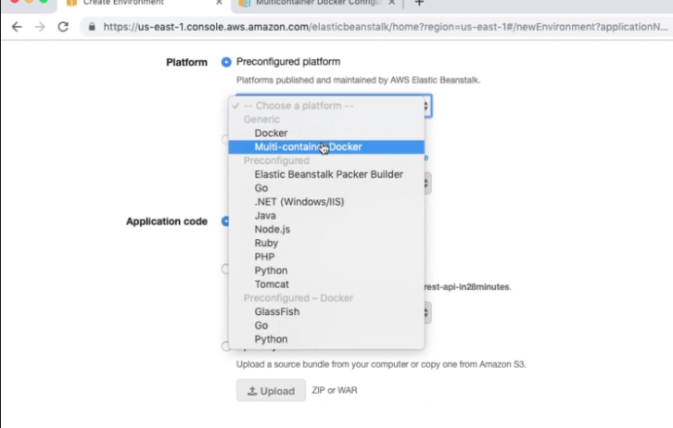

Check upload your code and select Dockerrun.aws.json

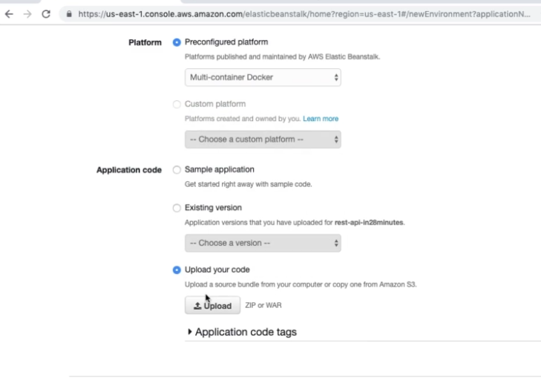

Give name to version level and select upload and select Create Environment

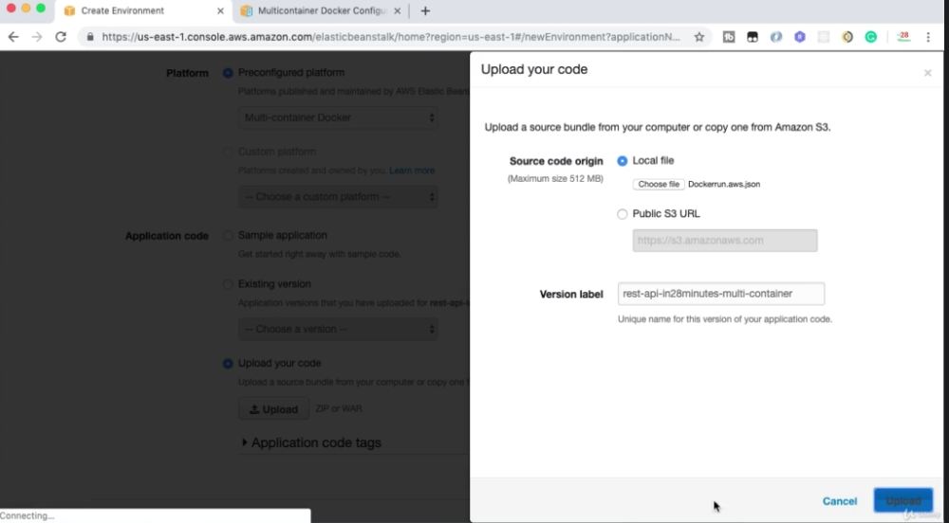

Elastic Bean Stalk uses **Elastic Container Service** to deploy multi container application.

Now if we hit the url, we will not be able to see the application running

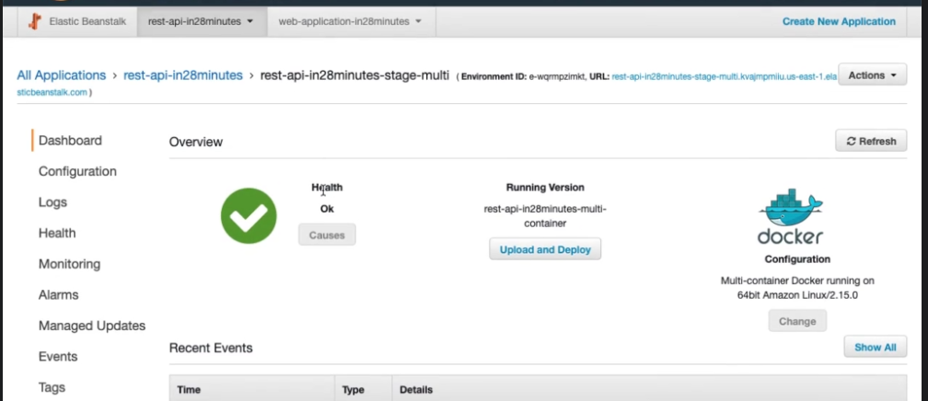

The reason is because in a multi container, and you run went there is no reverse proxy configured. You don't see nginx, or you don't see Apache http-server logs in here, because in a multi container and you document this stuff, are not really configured. And that's the reason why. What we would need to do is we would need to open up access to one of the container ports. What we are doing in here is we are exposing the port 5000. Because of this, The EC2 instance would expose the port 5000, but the security group of the EC2 instance will prevent traffic on port 5000. Let's see how to configure a security group and get it working.

**EC2 Security Group**

Go to EC2 dashboard and click security group

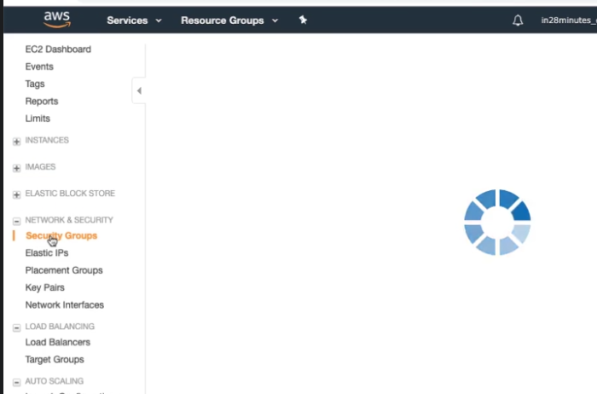

Open the security group related to your application

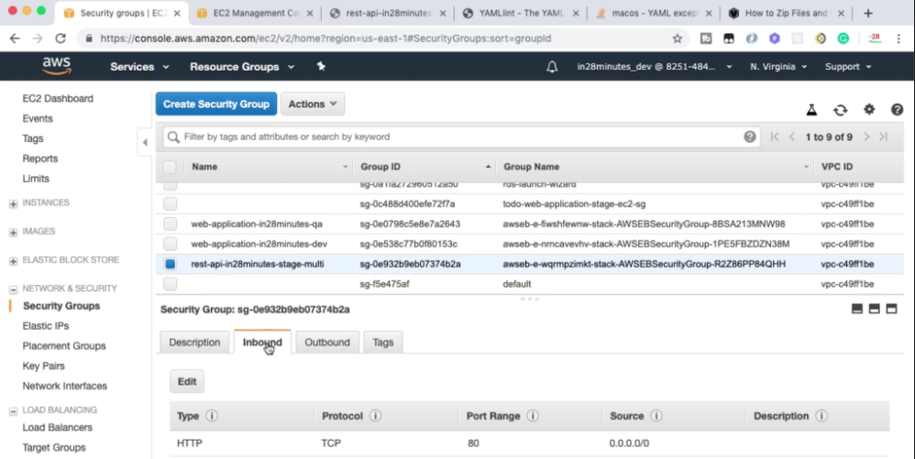

Select inbound->Edit->Edit inbound traffic rule

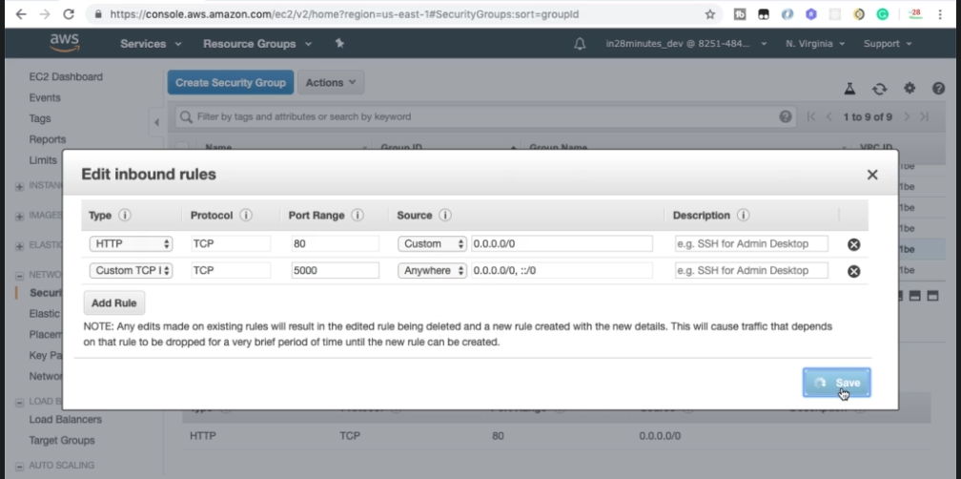

Now if you open the api url you will be able to access the url.

Elastic Beanstalk cli

**Blue Green Deployment**

When I want to deploy a new version in a particular environment there must be some down time. To overcome from downtime we first have to clone the environment and then deploy the new version into the new cloned environment and then swap the url.

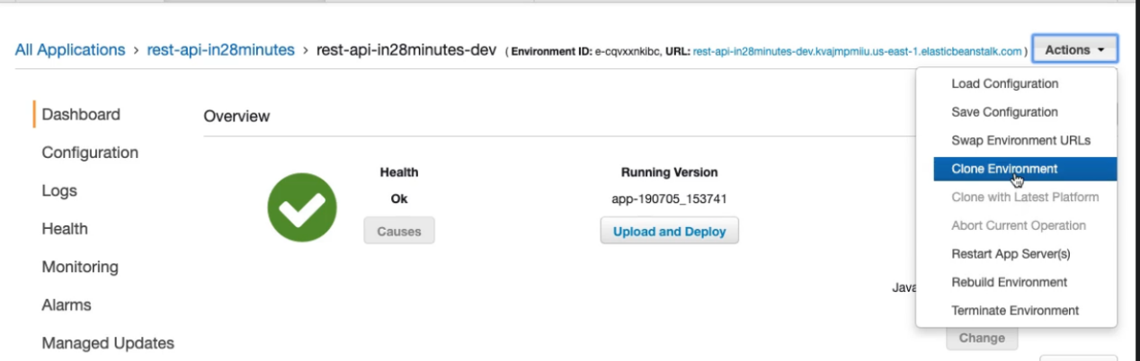

Next change the environment name and select clone. Next click Upload and Deploy and place your jar and deploy.

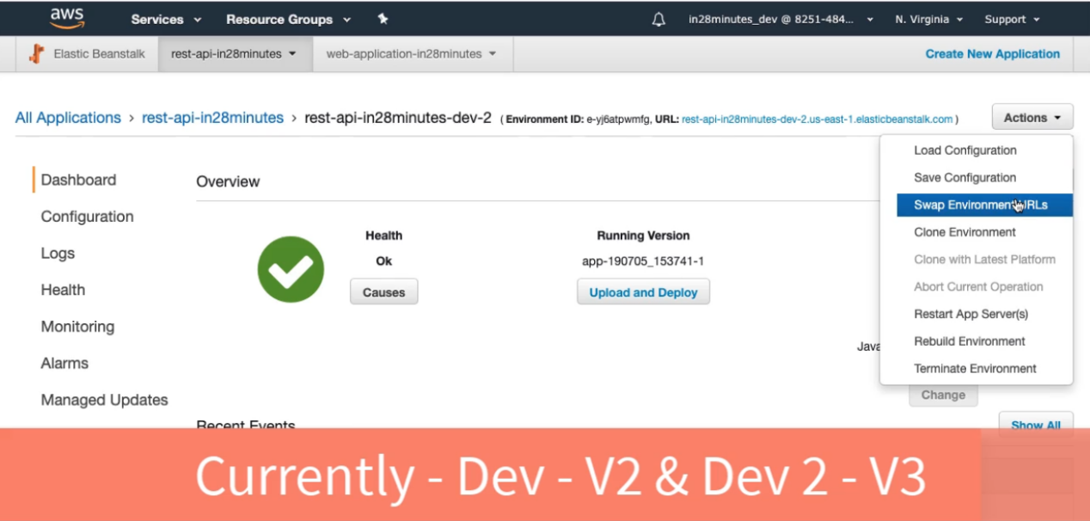

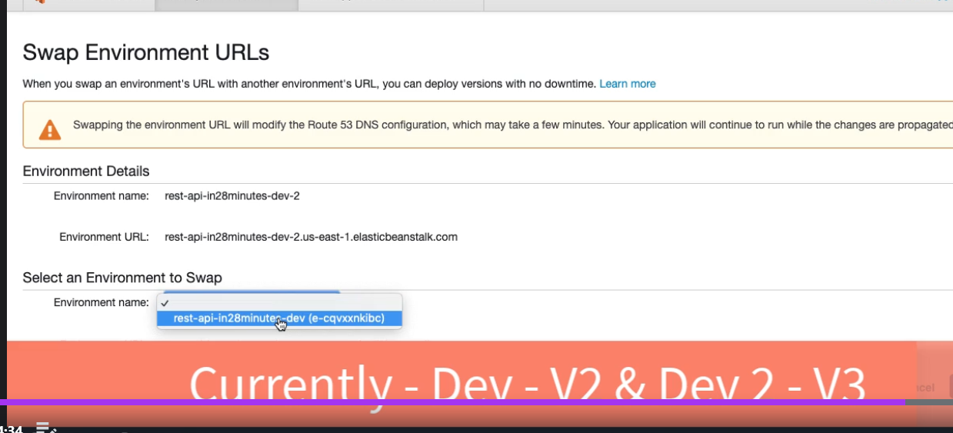

Now click swap.

Worker Environment where there is Queue configured and if you post your message this will be picked up by your resource by changing some configurations. I f some message processing fails this will be posted to Dead Letter Queue and will be processed automatically after 5 mins.

Deploying Multiple instances

Create a new Web Server Environment

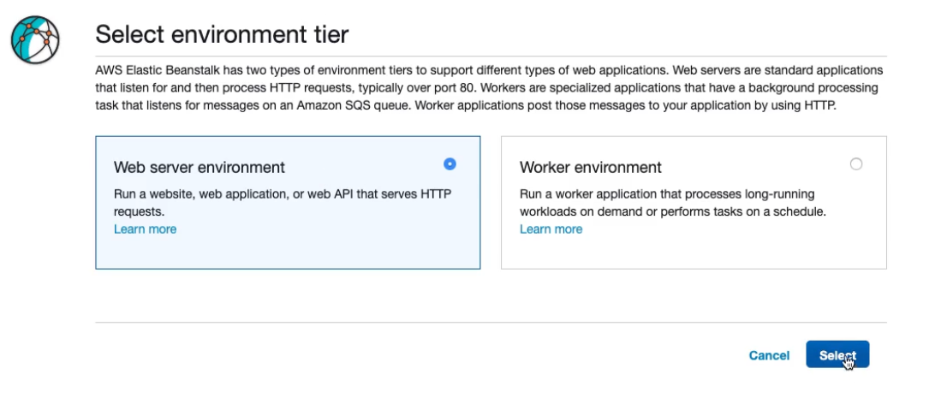

Give Environment Name, keep platform as java and we can use existing version of our application

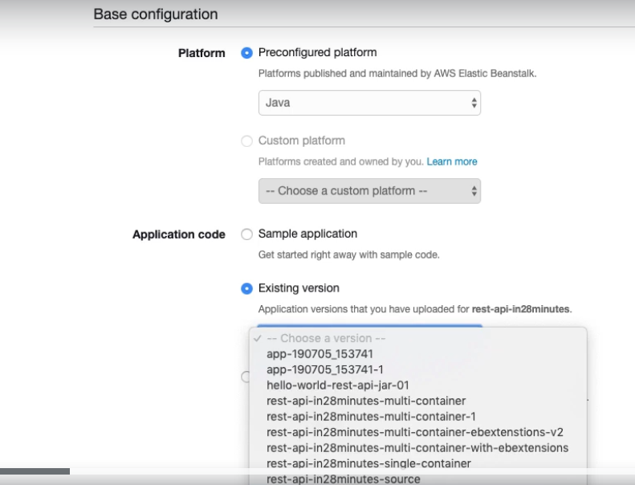

Select configure more options



In capacity click modify

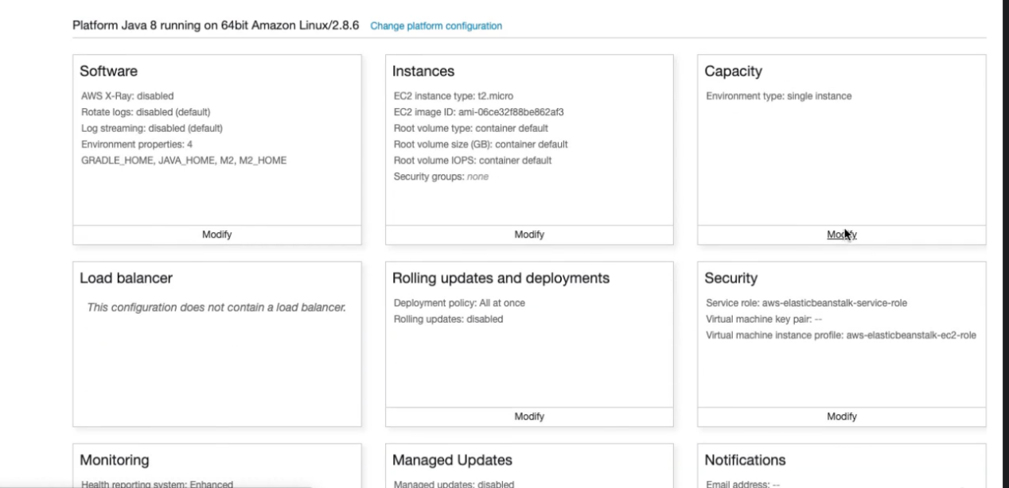

Select Environment type as Load Balanced and select number of instance. You can also choose Availability zone.

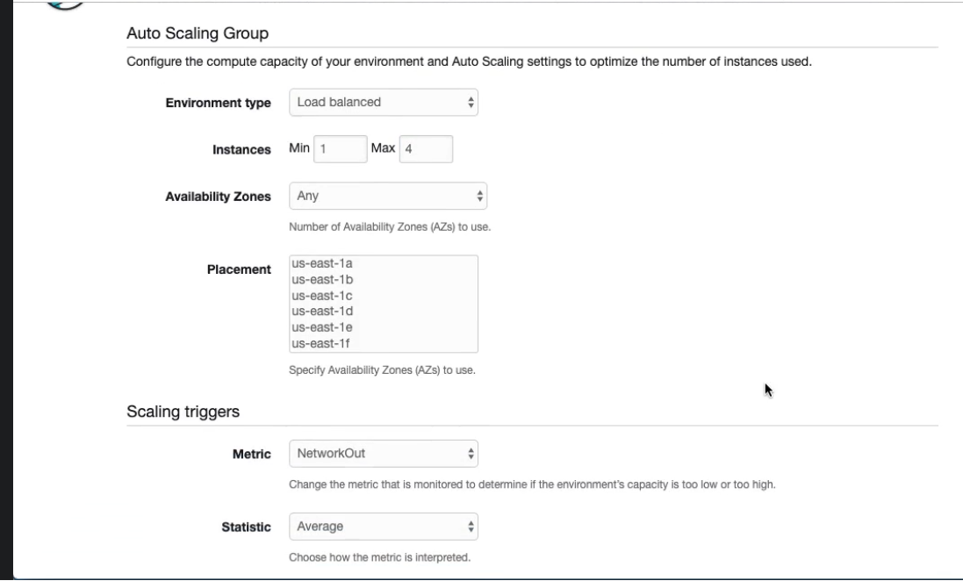

Based on when you require more instance and when you require less instances, you can configure as below

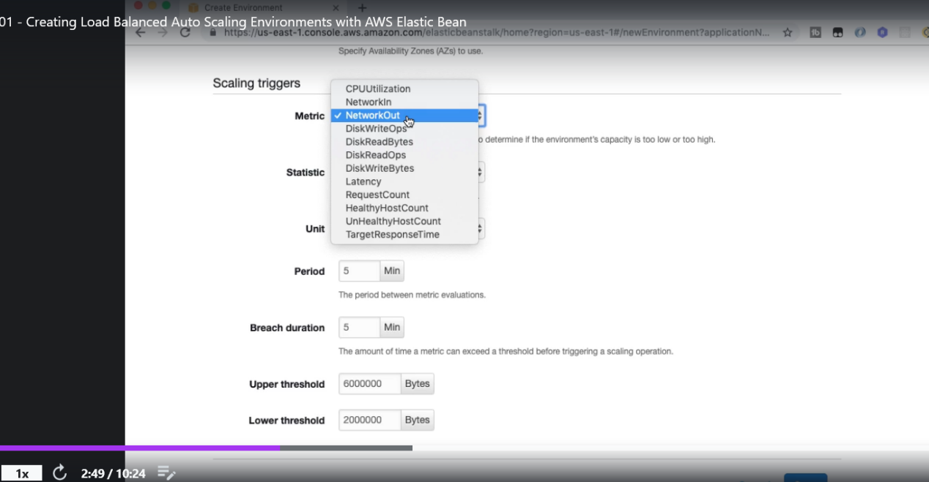

Example

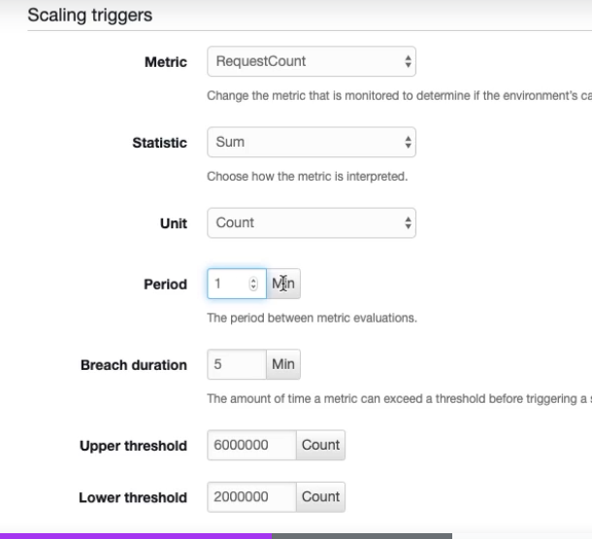

Set Upper threshold and lower threshold as 10 and 0. Select Breach duration is 1. So, if there are more than 10 requests in a minute this will increase instance. If we are below the lower threshold then the number of instances will be decreased.

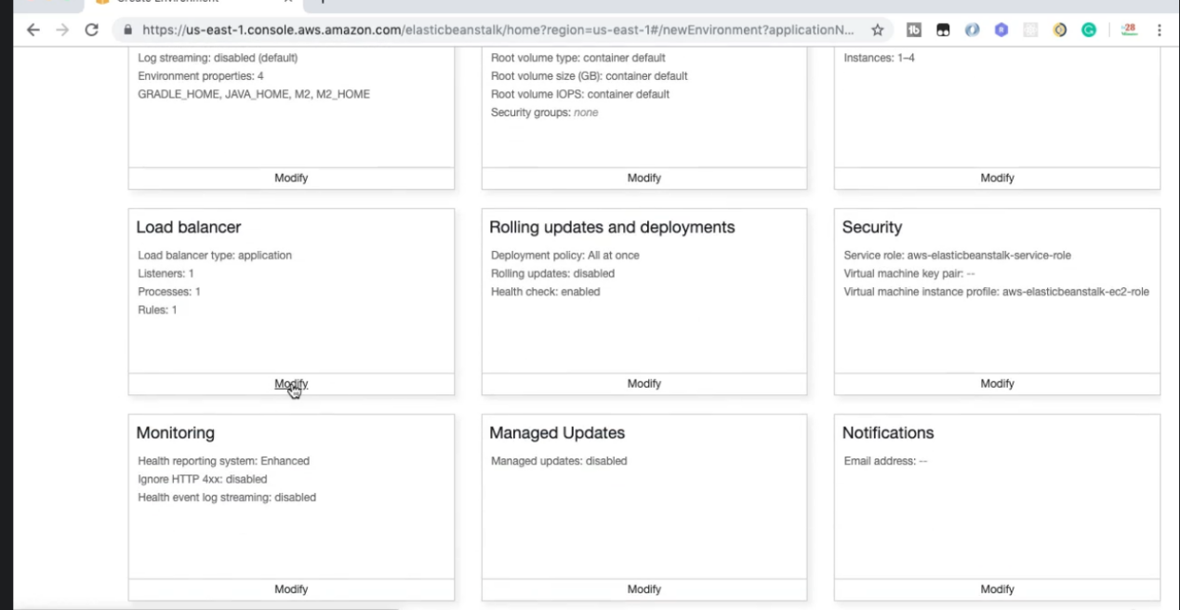

Click modify to Load balancer. There are three types of load balancer

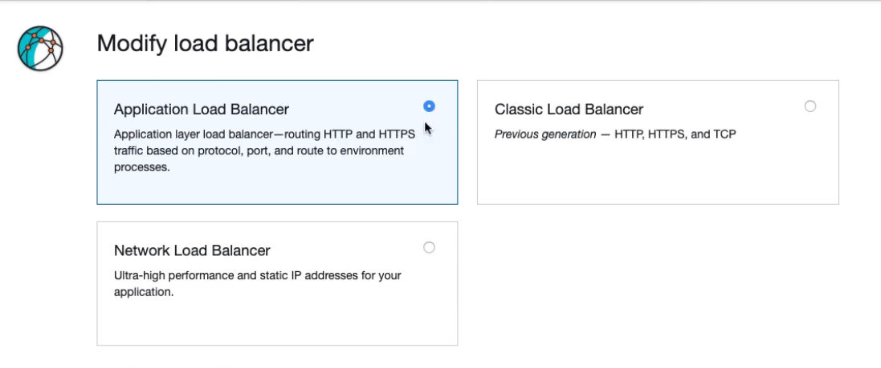

Classic Load Balancer is not used and network Load Balancer is used when high performance is required. Select Application Load Balancer and scroll down

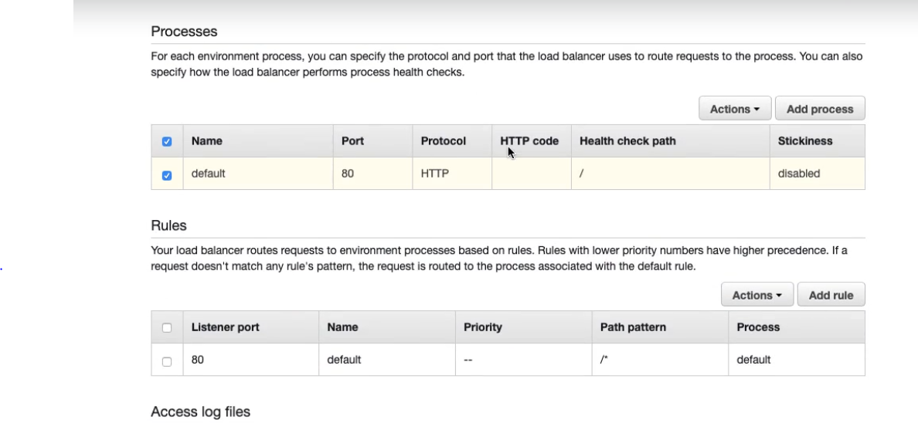

Select Action-> edit-> you can change health check path

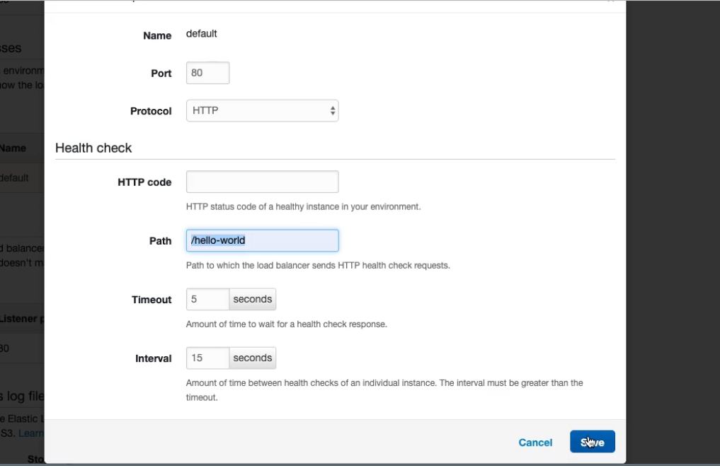

This will check the health of the given url and if for an instance this is down then the request won’t come to this instance.

Click modify to Rolling Updates and Deployments: this will tell if 4 instances are currently running then how a new version can be deployed.

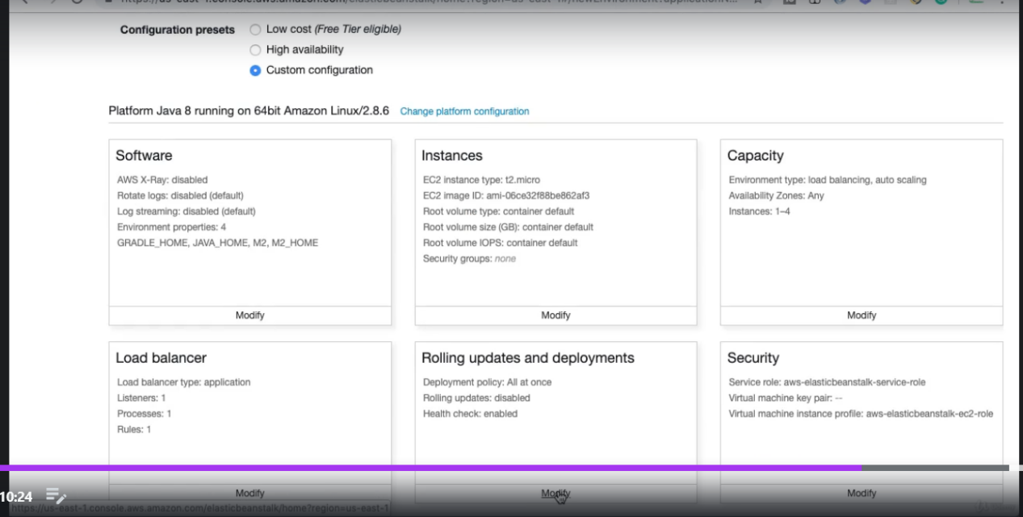

For example if we select All at once then there will be downtime. Rolling means updating 1 instance at a time. Rolling with additional batch will update the mentioned number of instances at a time.

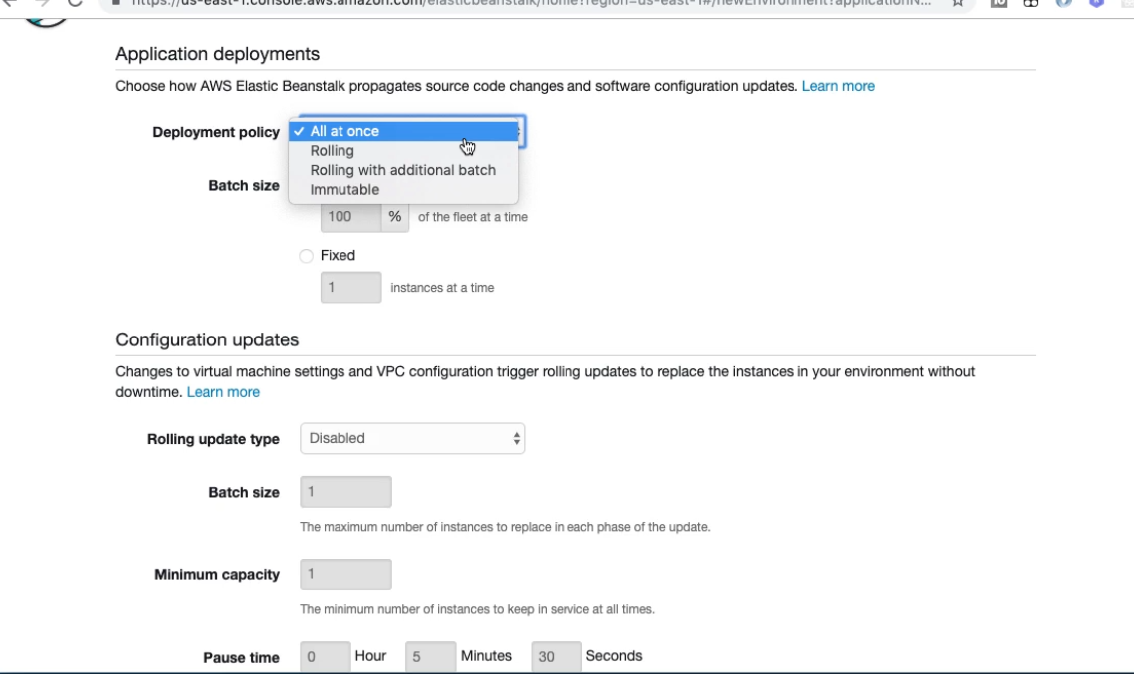

Example  
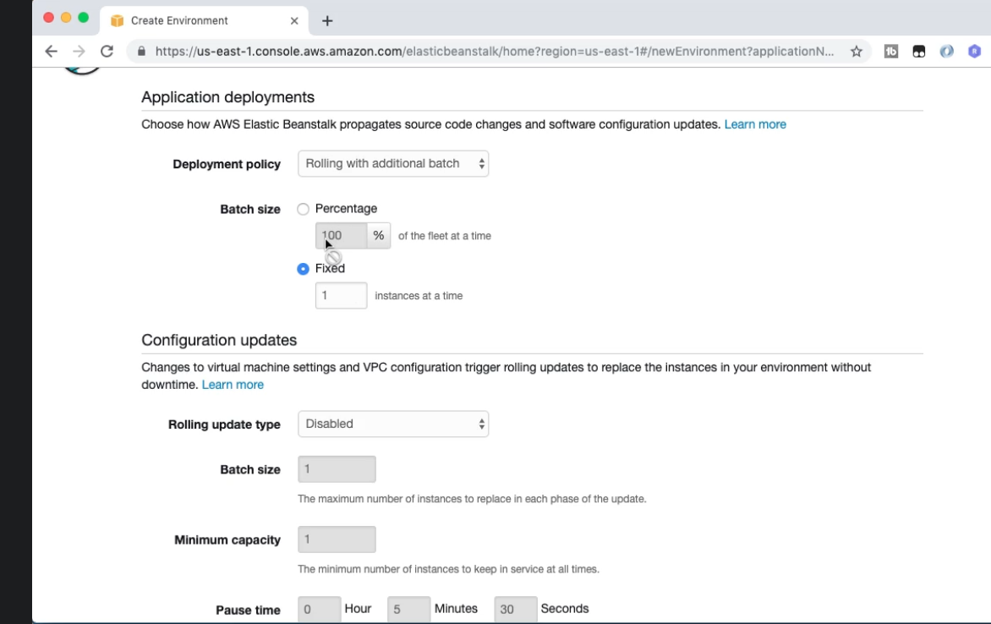

Click save and create environment.

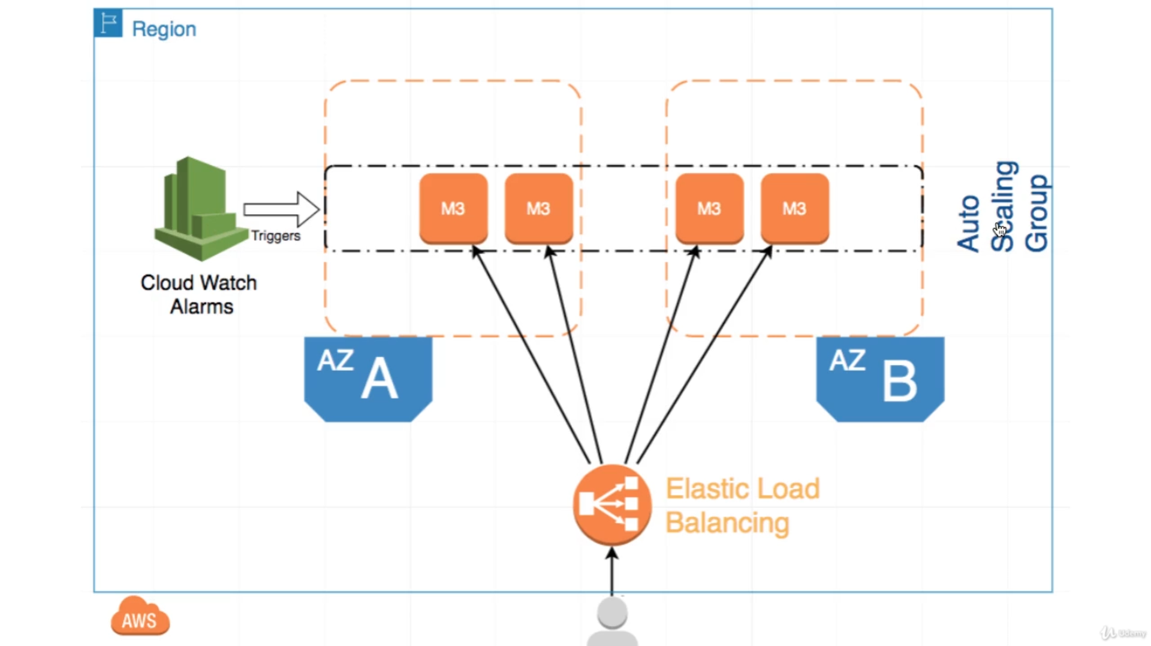

elastic load balancer.

It said let us get a good theory update, on what's happening in the background right now.

Let's assume a scenario where there are four instances running.

So let's say therefore the EC2 instances which are running at this particular point in time – all these instances would be load balanced by something called elastic load balancer. You can see that all the things that we see are in something called a single region. So this is what is called one region.

So we will using us E1north Virginia, as the region until now.

So this is this specific region, and inside this region,

There can be multiple data centers.

So as we saw earlier north Virginia at this particular point in time, has six Availabilitty Zones - so they can be and is available.

Is at the A, B, C, D. the A,B,C,D labels I am giving it might not be the actual name.

So there will be six or five available days, on typically the number of Availability Zones will be greater than one 2 in every region.

There'll be at least two Availability Zones.

Now why do we need Availability Zones?

The reason why we need Availability Zones, is because when you deploy an application, and you have let's say three instances of an application, and if let's say all the three instances are in the same data center, what would happen if that data center some flood or something happens - a national calamity happens ->

then your application is completely down, and that's the reason why you would want to spread your applications across multiple Availability Zones. AWS would ensure that these Availability Zones are as far as possible

I mean they are in a single region, as far as possible in a single region, and that gives you more availability.

The great thing about the Elastic Load Balancing is it can load balance between applications which are deployed in multiple Availability Zones, so you can load balance to applications and availability Zone A, and availability zone B as well.

Earlier, we configure the maximum number of instances, and we will a

number of instances - let's say the maximum number of instances that can be possible are 10, right up there

4 instance is running.

Who makes the decision as to increase the number of instances earlier?

We configured this killing rules while we were creating the environment. Both killing rules are configured

as cloud watch alarms, that will be alarm set, saying that if average number of requests is greater than

this much amount, you need to increase the number of instances.

If the average number of requests is less than a specific amount, then we have to decrease the number

of instances - to make it easy for cloud which alarms to trigger the policy.

What would happen is there is something called an auto scaling group created. This auto scaling group

consists of all the instances that are active at this particular point in time, and whenever a threshold

is exceeded - whether it's at the maximum or the minimum - the appropriate action is taken by the auto scaling

group. In the earlier step,

We also talked about how these instances are updated ,when there is a new deployment.

The options we talked about was rolling updates, and immutable updates. Rolling updates had two options

just rolling update, and rolling updates with additional instances. In the case of a rolling update,

the way it would be done is - let's say there are four instances right now, and a new version of the application

needs to be deployed.

What would happen is each of these instances - first the let's say this instance is updated with the new version.

So at that point in time only three of these versions are available.

Once this version is active, then the next instance is updated, and so on and so forth.

In rolling updates with additional instances, what would happen is a new instance would get created in

the same or the scaling group.

Once it's ready and passed the health checks, then it would replace an existing instance, and so on and

so forth.

The same thing happens for all the instances in the case of an immutable update.

The thing which would happen is, if I have 4 instances running at that particular point in time, what

happens is first a new order scaling group would be created, and a new instance would be added to it.

Once the new instance is passing the health checks, what would happen at that particular point in time,

is the instances in body or old Order scaling group, and the new order scaling group.

All of them would be balanced by the elastic load balancing - so there would be five instances serving

the requests.

Slowly it would become 8, because all the other instances would be added in, and wants to have all the

things which are processing and handling the request successfully.

Only then the old instances are terminated. Before terminating the all instances, what elastic means stack

would do is transfer all the new instances from the new auto scaling group, to the old auto scaling group.

One of the things you need to remember is in the case of immutable updates, for certain amount of time,

you would actually be utilizing double the actual capacity - so each row for instance as you will be having eight instances which are running, but immutable updates gives you the chance of rolling back very very

quickly in case of a failure.

**CloudWatch**

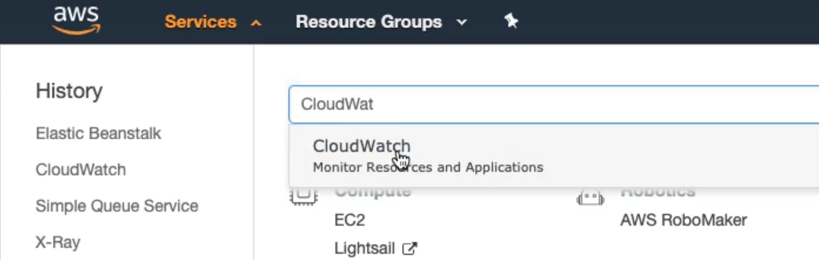Go to services -> select Cloud Watch.

Cloud Watch is used for monitoring applications, configure alarms.

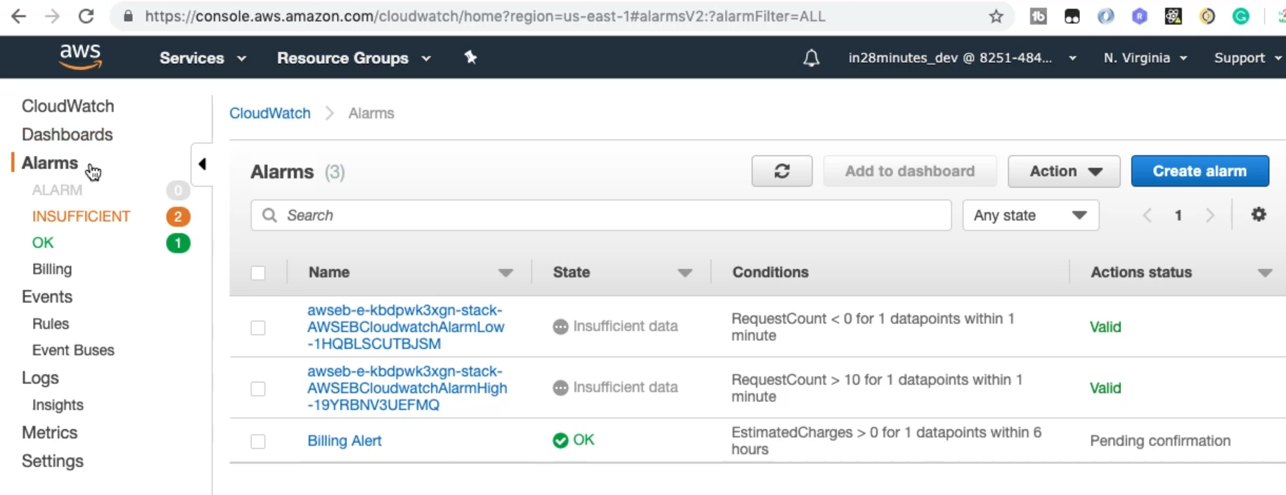

Here we can see that 2 alarms are set from load balancer service. When there is no hit the status is Insufficient data, when the number of request per minute is >10 then the status is Alarm and the number of instance is increased.

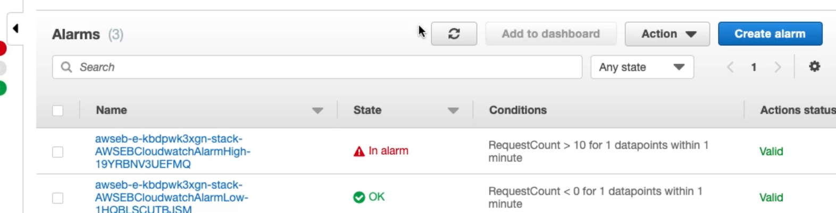

Click on the first url you can see graphical representation and if you scroll down you can see the logs. Also you can check the events (We have separate option for events).

When you deploy a new version you have the option for choosing the strategy.

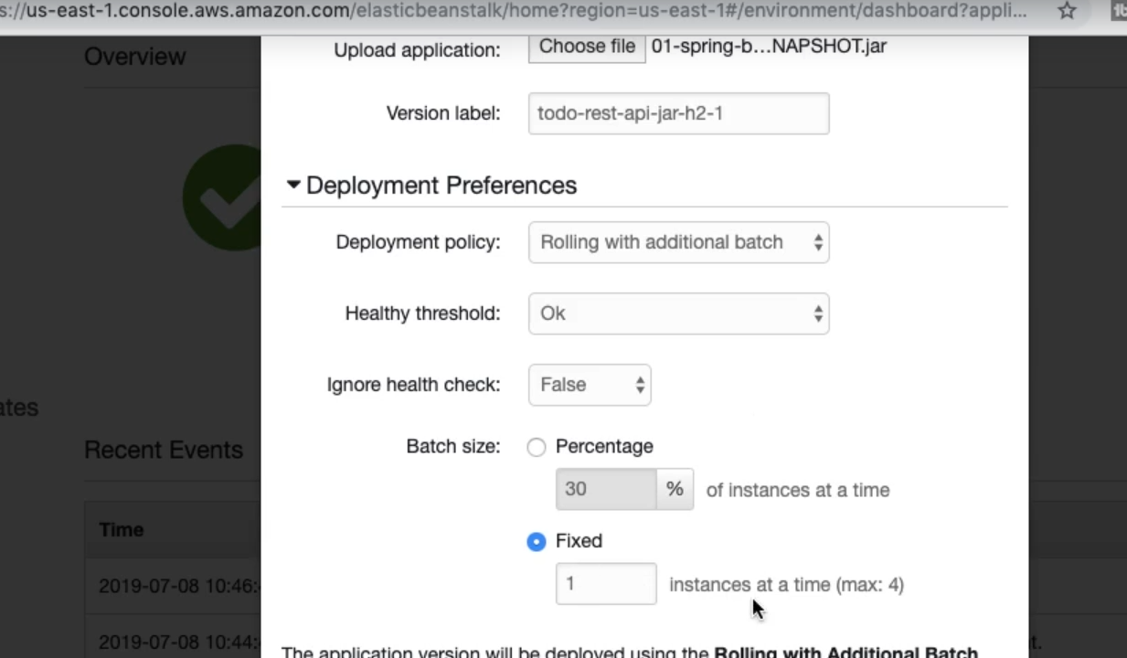

**Kubernetes in AWS**

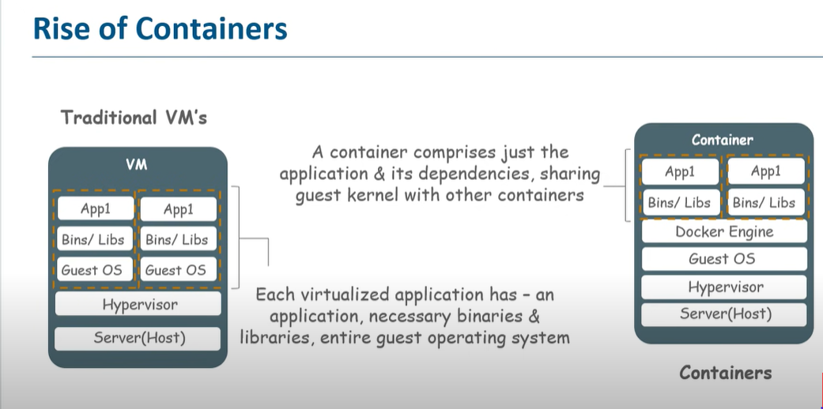

Each virtual machine has its own operating system, this makes vm’s heavy but containers have only applications and libraries. So, in the case of containers a single guest OS host machine can run many different applications.

To create a container we need docker. Using docker we can create, deploy and manage virtualize application containers on a common os.

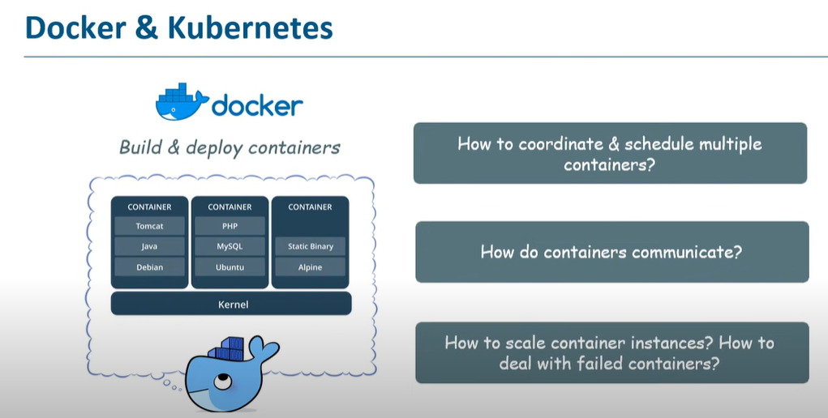

Managing containers is a very tedious job. Kubernetes helps in managing containers. Using kubernetes you can run multiple containers in different machines, you can distribute load in different containers etc.

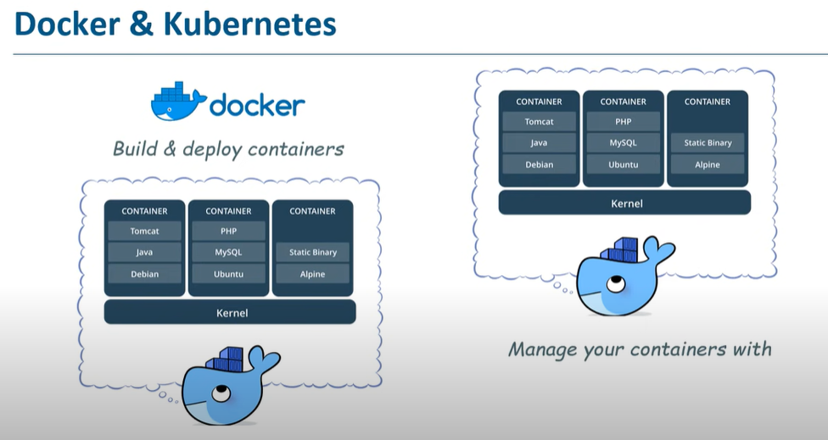

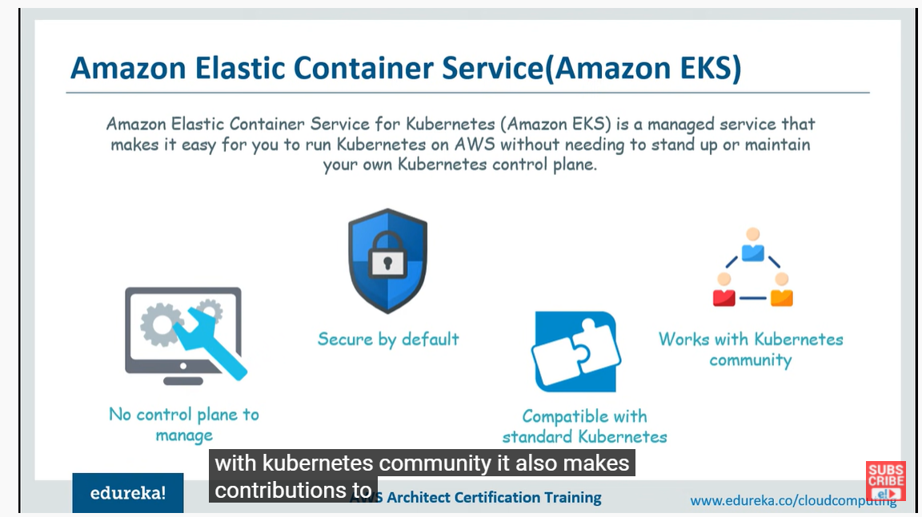

**Kubernetes Deployment Single Container**

Deploying Single container application

In your spring-boot application pom.xml add below plugin

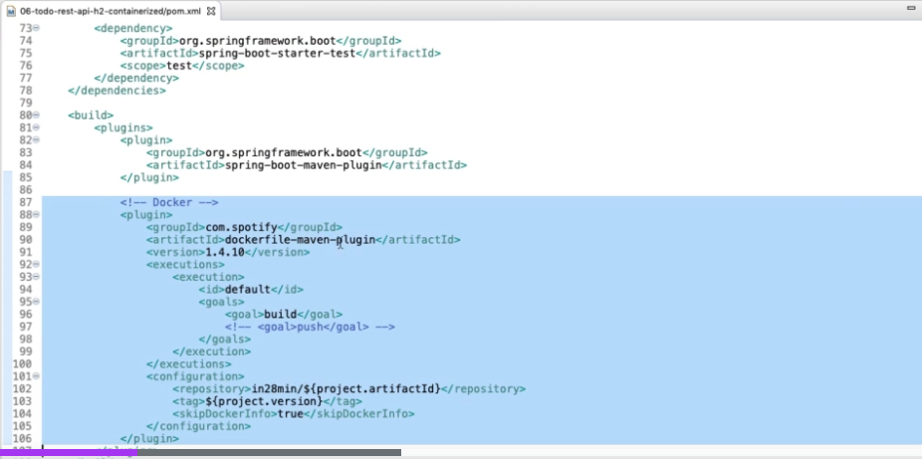

Also we need to add dockerfile in our application. A dockerfile helps us to create a container. This plugin helps us to run the instructions inside docker file.

After writing ‘mvn package’ after adding the plugin, you would create a docker image along with a jar. In the plugin you need to mention docker hub repository name. So, here an image will be created with tag version as (project.version)

Docker File

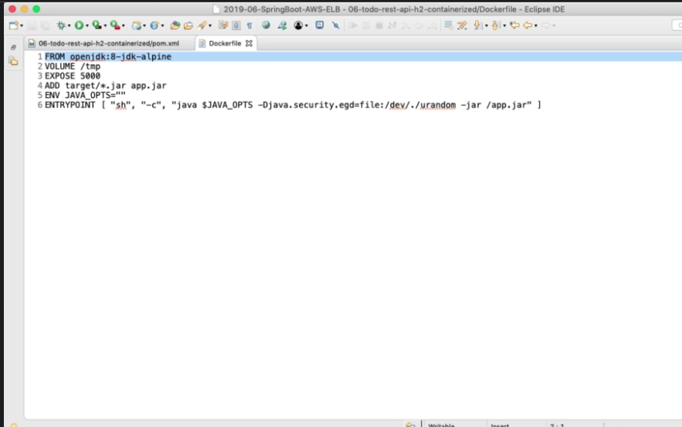

We are taking a image from open openjdk:8-JDK-Alpine. we are specifying a temporary directory - we are exposing the port 5000. When we run the build, everything would get created in the target folder.

The deploy able jar where it would be present it would be present in the target folder.

So what we would want to do, is we would want to take that jar and name it as app.jar. So inside the container we are copying a file called app.jar. In JAVA_OPTS option you can configure memory.

Now run ‘mvn clean package’ this will create an image locally. Docker must be running in background.

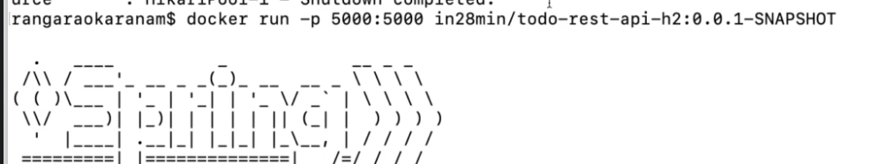

This will run the image.

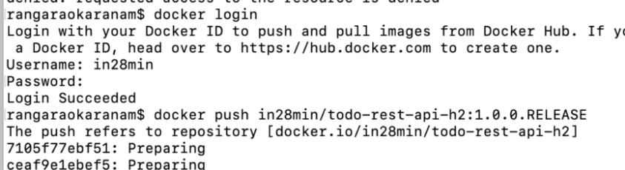

This will push the image into docker hub.

Deploying image to AWS

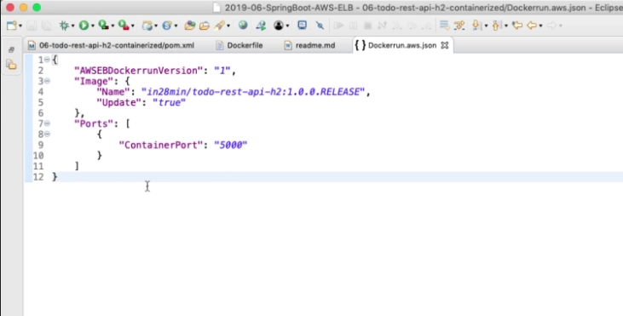

Create Dockerrun.aws.json as above in project level.

Inside ElasticBeanStalk create a new environment.

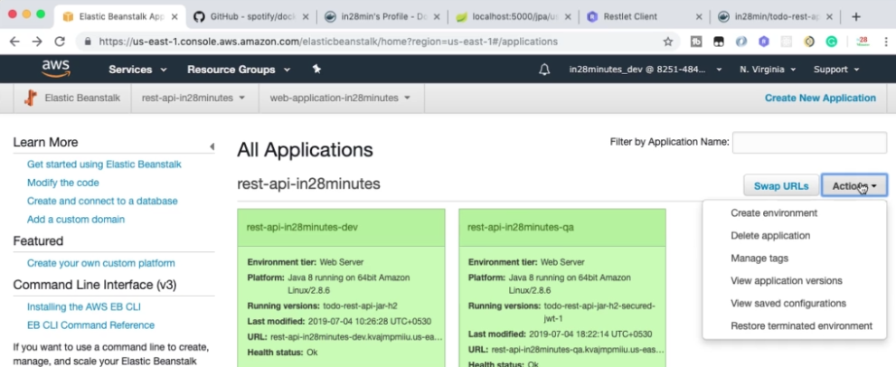

Select WebServer Environment

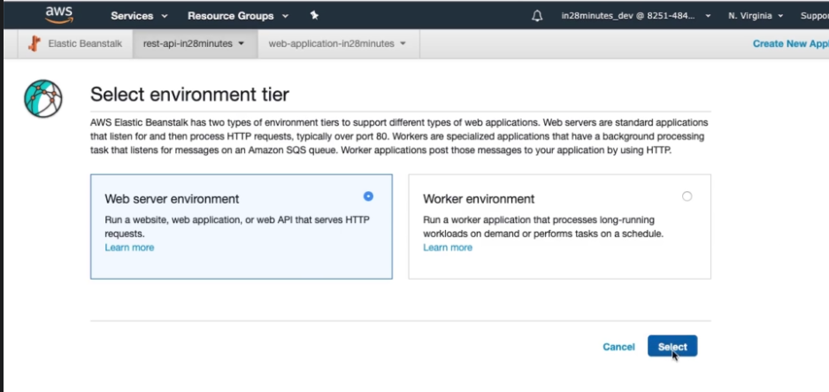

Add below details

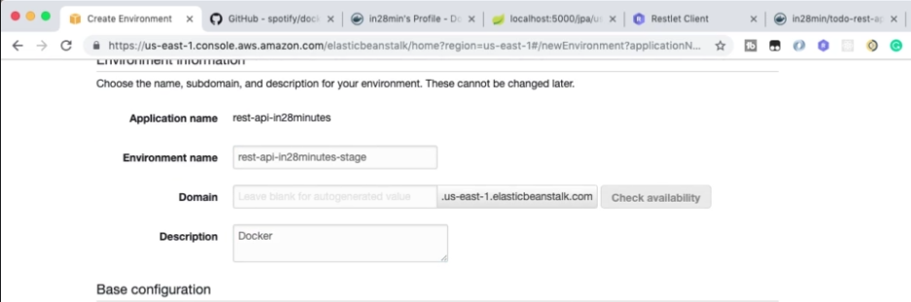

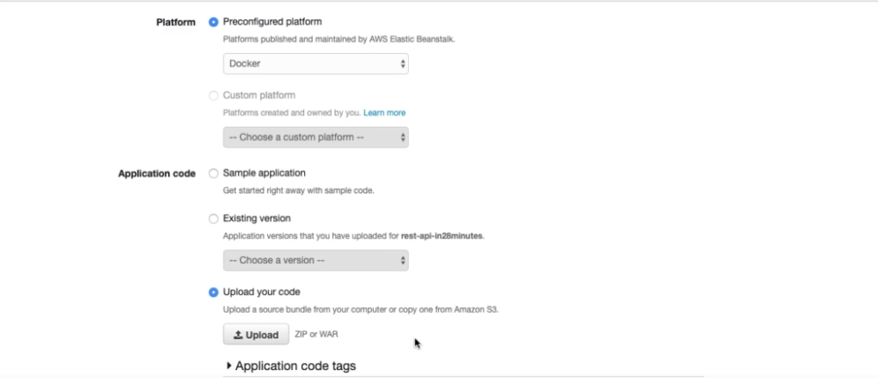

In the upload option upload Dockerrun.aws.json file. Then click create environment.

This will pull the docker container from the docker hub and create the entire environment for us.

Now if you hit the url. You can see the response. You can also check the logs, health and other options.

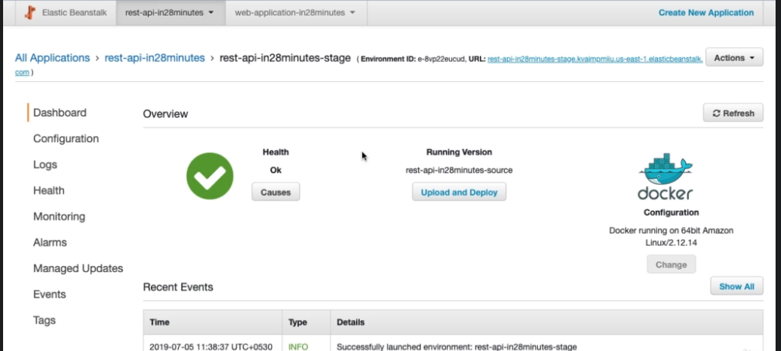

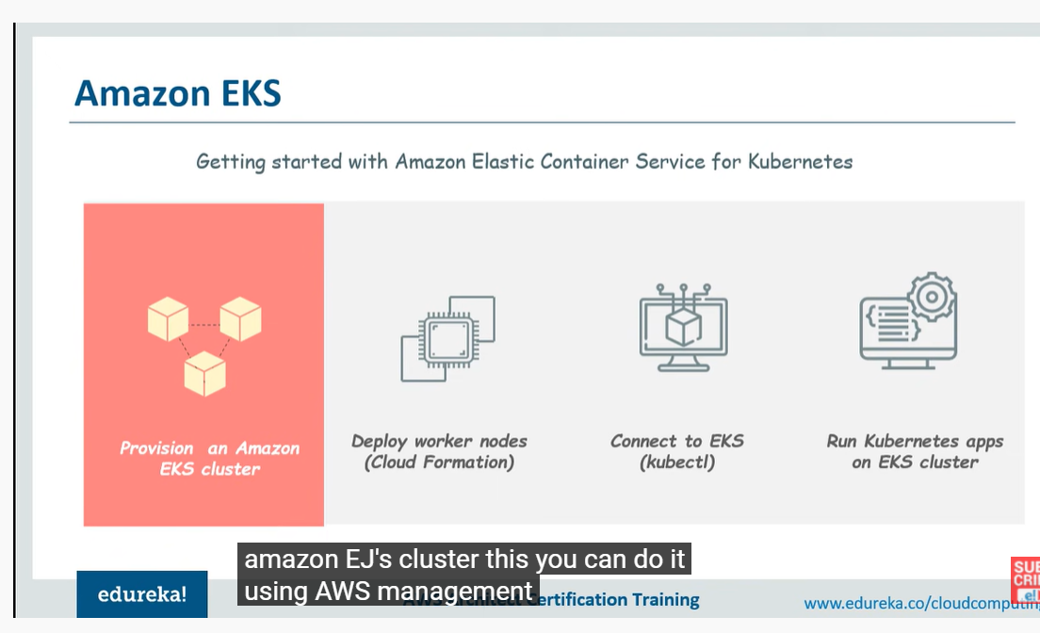

1. Create an amazon EKS cluster. Before that Create an IAM role to assign permission to your kubernetes cluster and VPC and subnets on which your cluster can work on.
2. Secondly, you need to create worker nodes and add them to the cluster which you created. create VPC and security groups in your cluster. (using CloudFormation -> Stack)
3. Configure them so that they are attached to cluster successfully.
4. Once cluster and worker nodes are up and running successfully then launch your application.

(For accessing kubernetes cluster -> Install kubectl.

Install aws-iam-authenticator.)

Before creating AWS EKS cluster there are certain prerequisite, first we need to create an IAM role, this is mainly to assign permissions to kubernetes to control resources on your behalf.Secondly, you need to create one VPC and security groups for your cluster to use.

Creating IAM role

—------------------

Search IAM in AWS services, click IAM

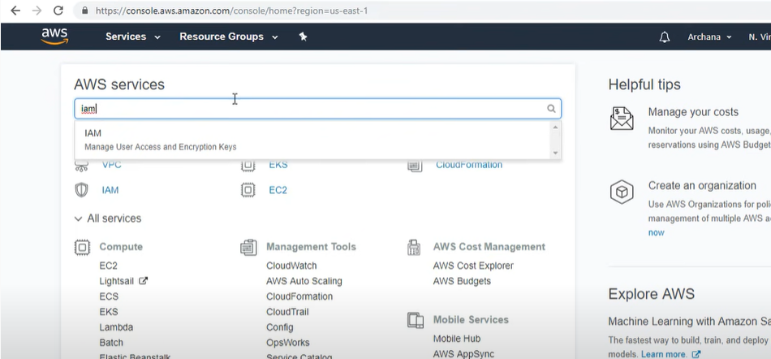

Click on roles

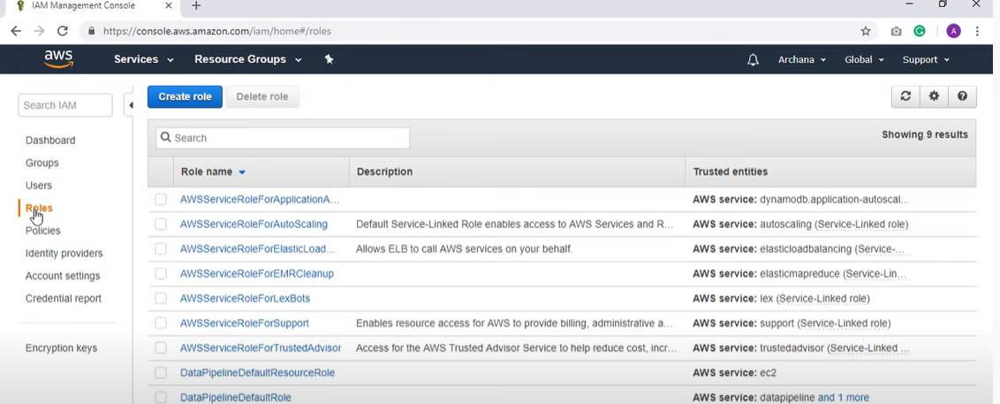

click on create role

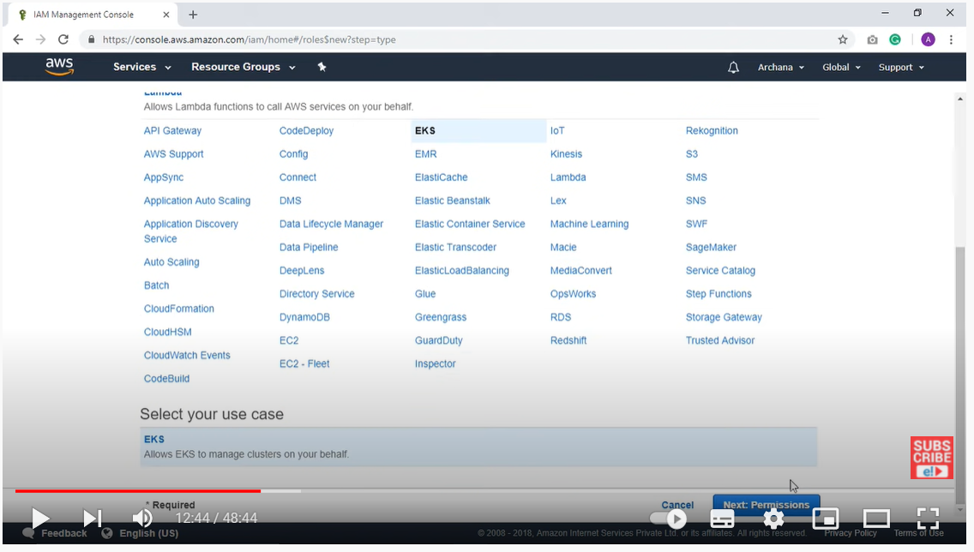

Since we are assigning permissions to kubernetes services, so select EKS here, click Next Permission

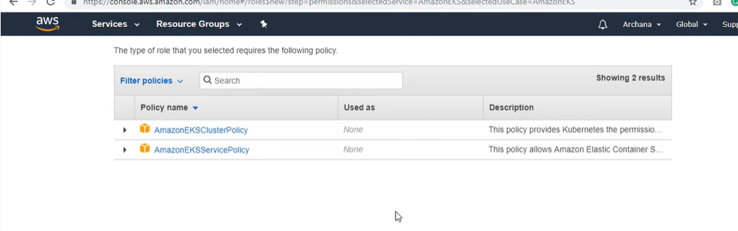

As this role follows two policies, the above two policies are created. The first one assigns permissions to kubernetes to manage resources on your behalf and second policy assigns permissions to EKS to create and manage necessary resources to operate Uk’s cluster.

In the below you have review option

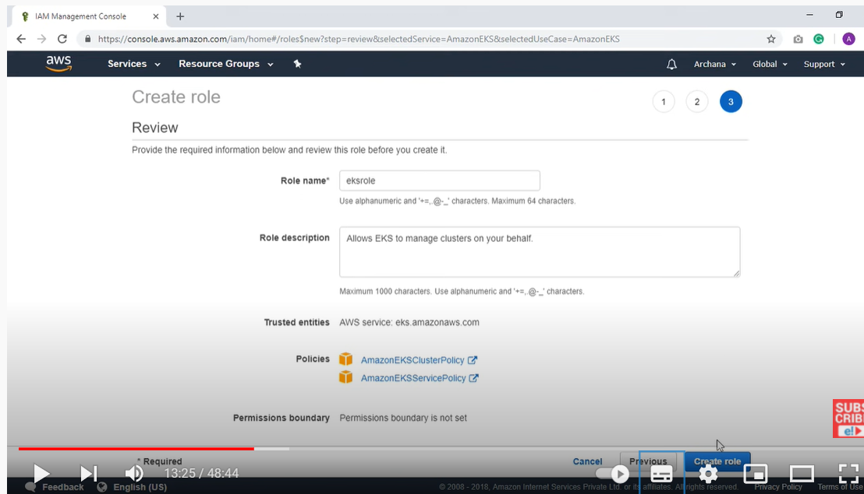

give Role name and click create role.

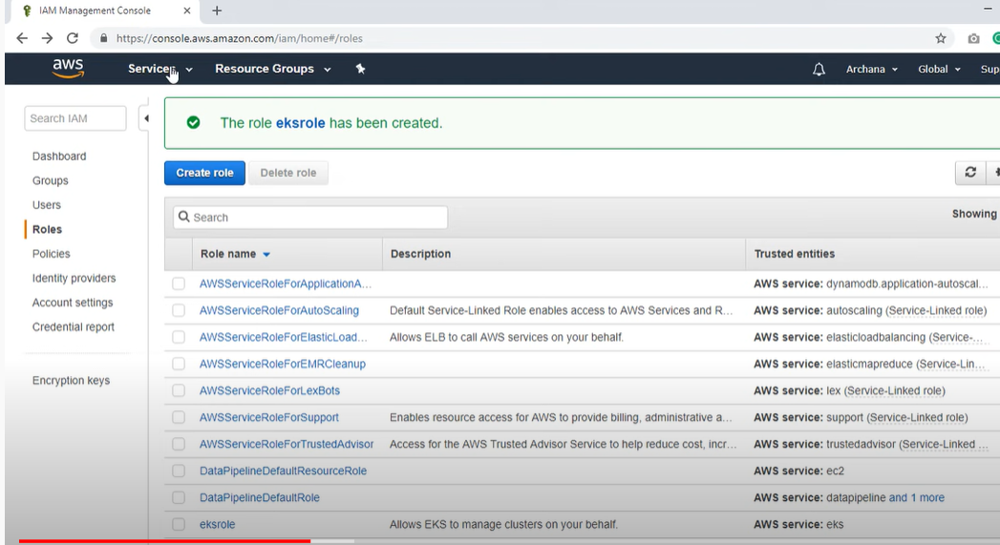

Now you have to create vpc and security groups, these are resources that you use in AWS cloud. We can create them using cloud formation template

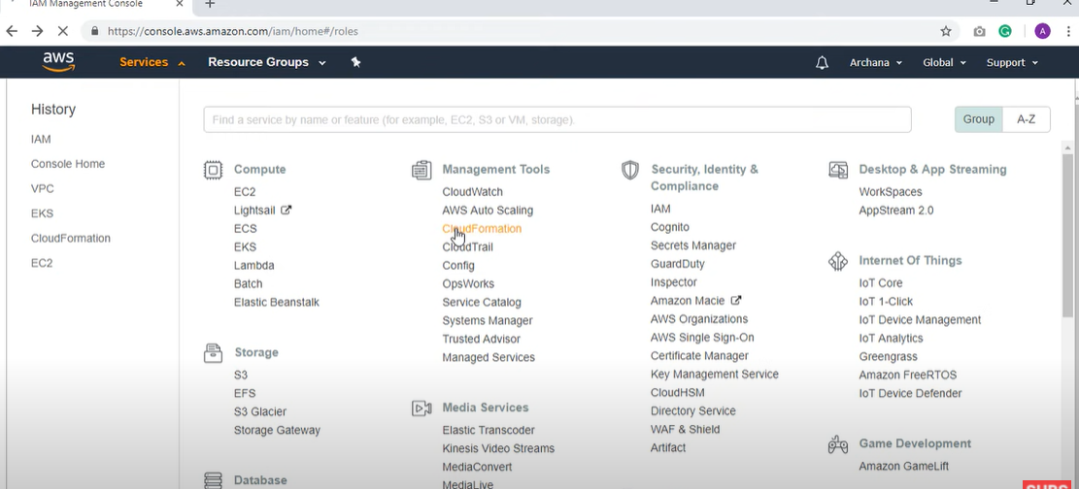

Cloud formation is a service which allows you to use a single text file to manage all your resources that you are using on AWS cloud

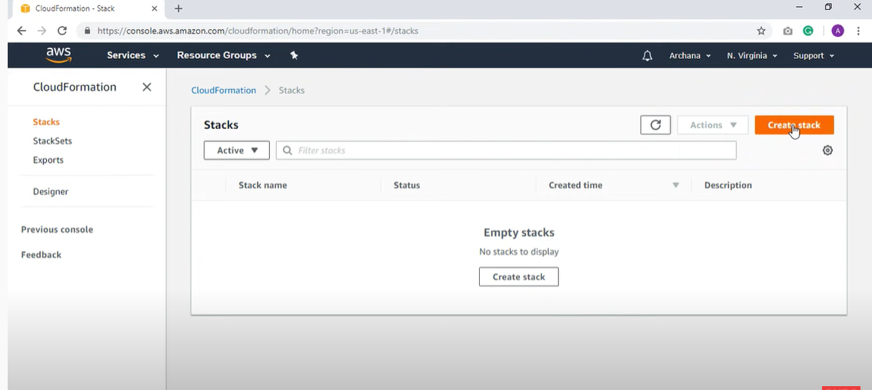

This is the cloud formation console and click Create stack.

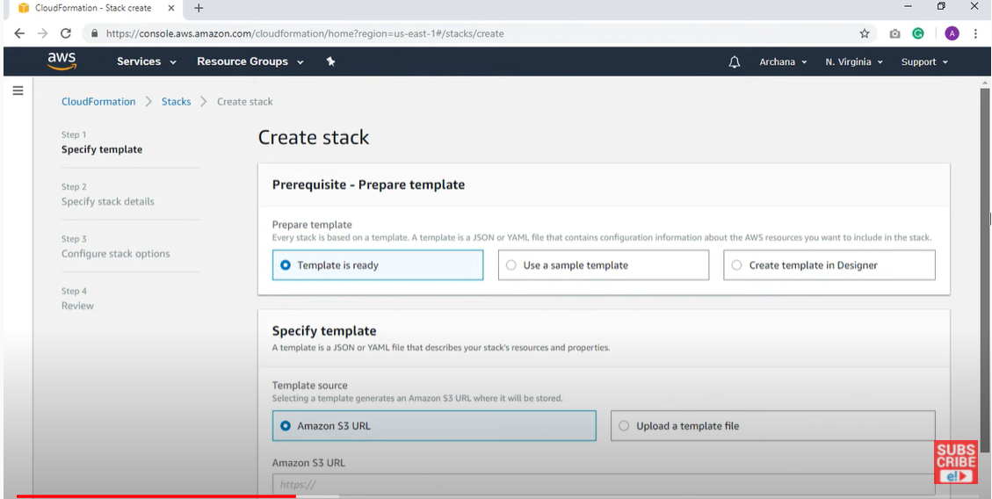

Here you can use a sample template. So, you need to provide an Amazon S3 URL.

Open Amazon EKS documentation

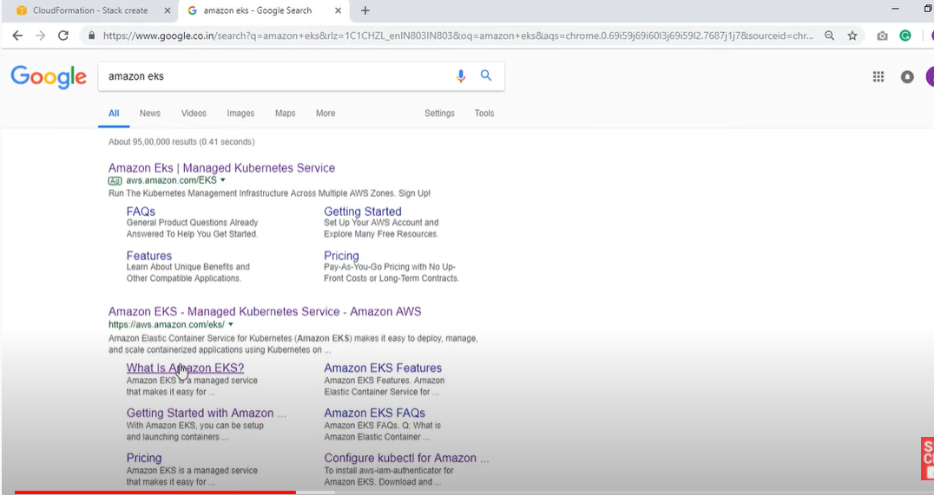

Click on getting started

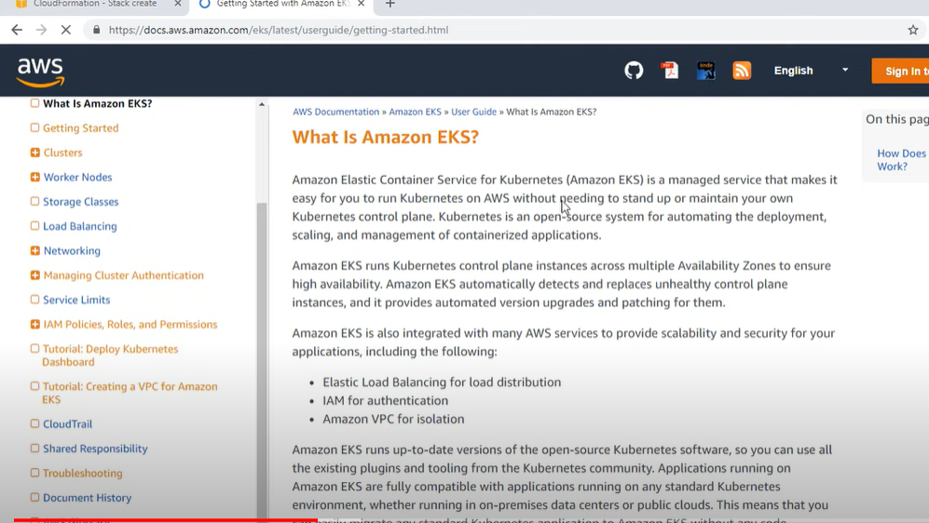

If you scroll down you can get the url below. This url is going to create a VPC and a security group and three subnets.

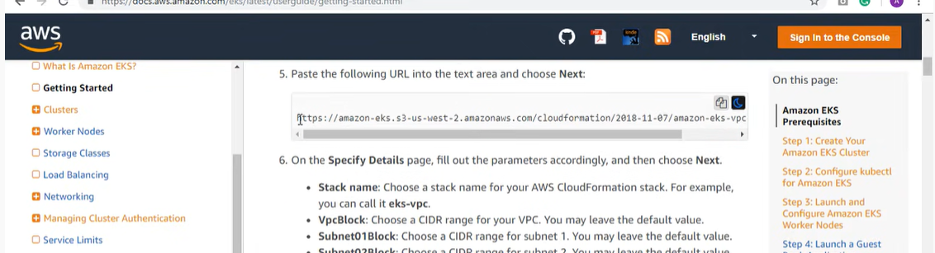

Provide the url and click next. Give Stack name. Click next. Next steps are optional and click create stack. We can also create above steps using VPC

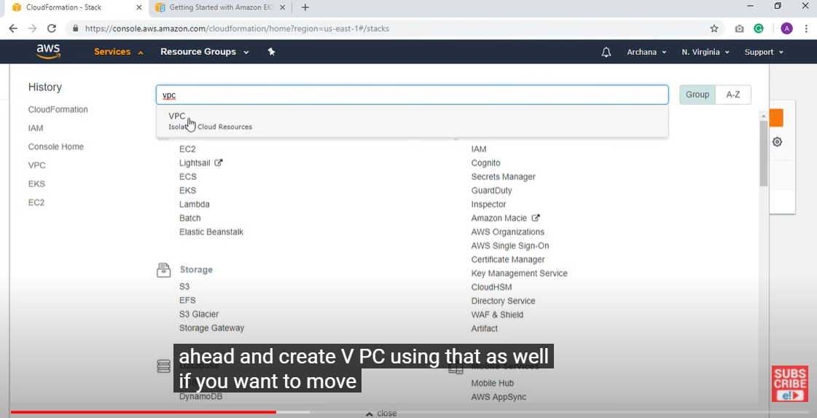

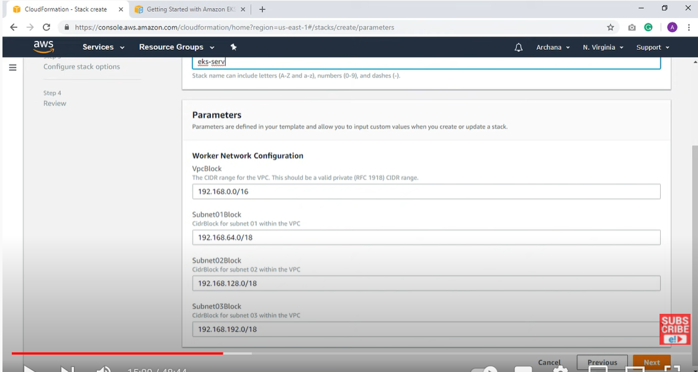

Next we need to create a cluster.

If you go to the stack you created and go to the outputs tab and copy details for later use.

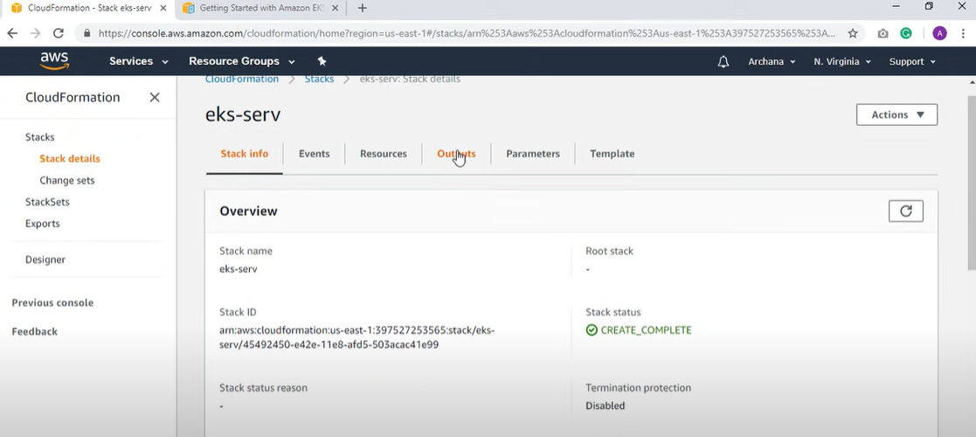

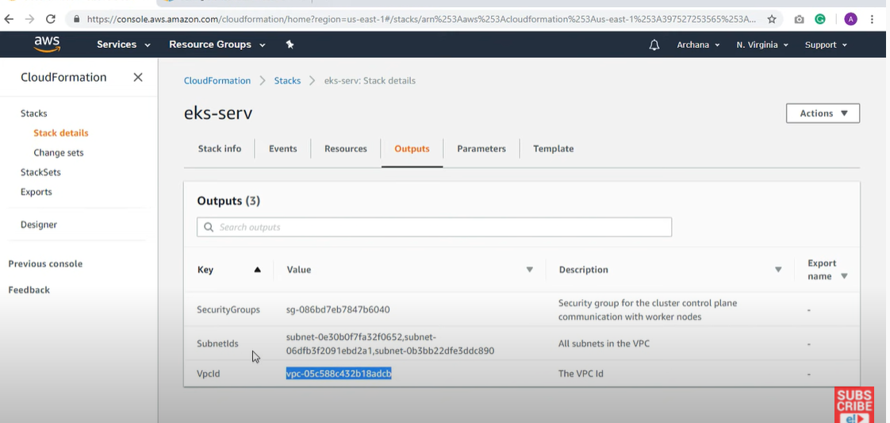

Click EKS for cluster creation-> click the next step button.

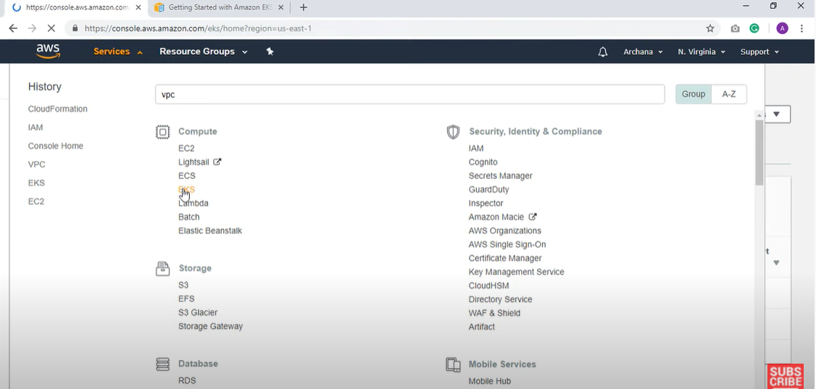

Give a name and give the vpc id you created, select role

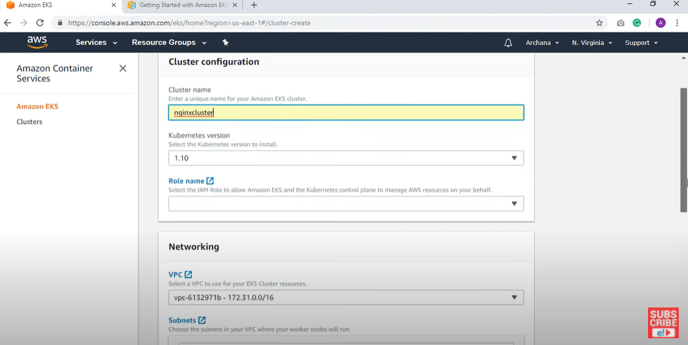

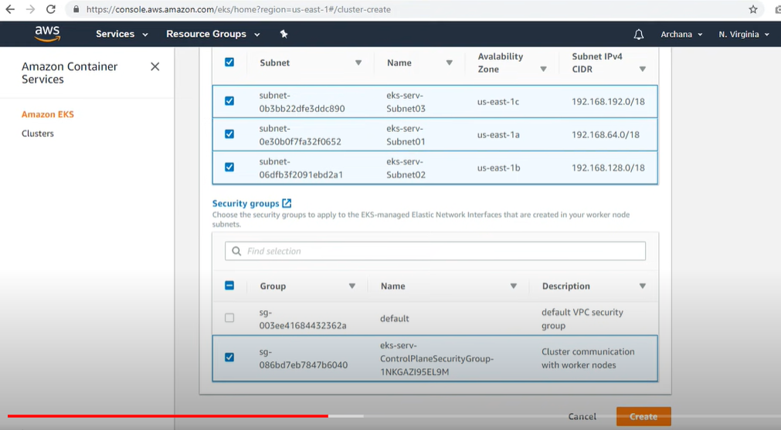

Click create

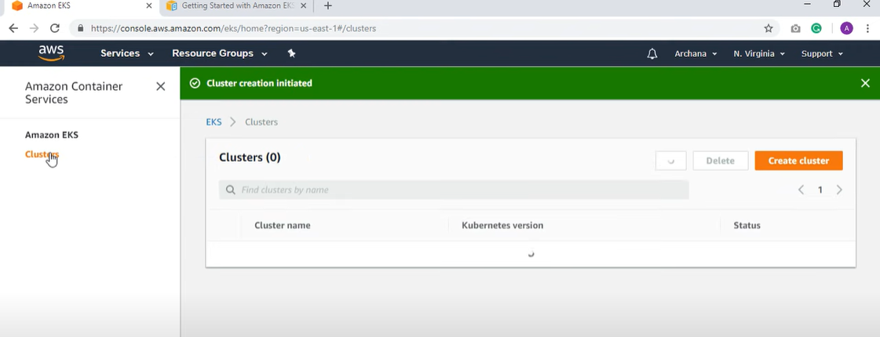

Now we need to install kubectl.

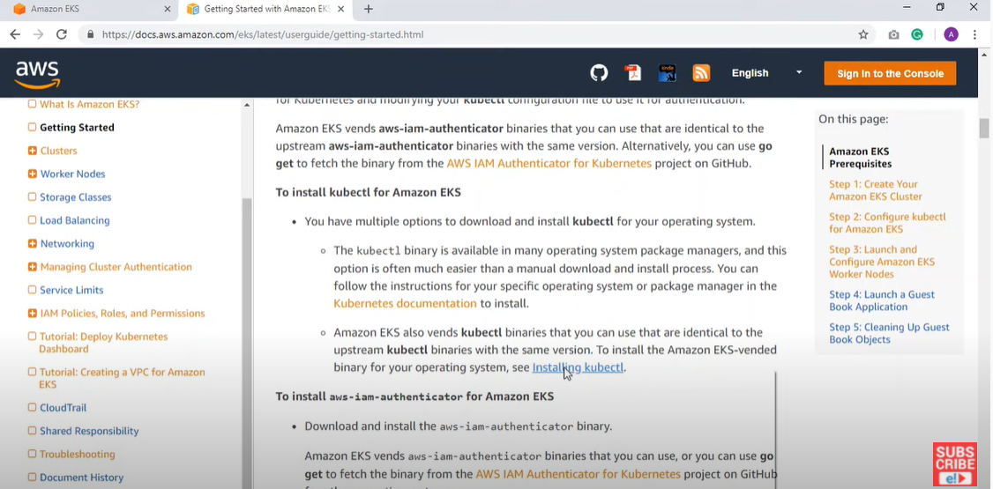

Create a folder in your computer and keep the kubectl.exe file. In the environment variable add the path

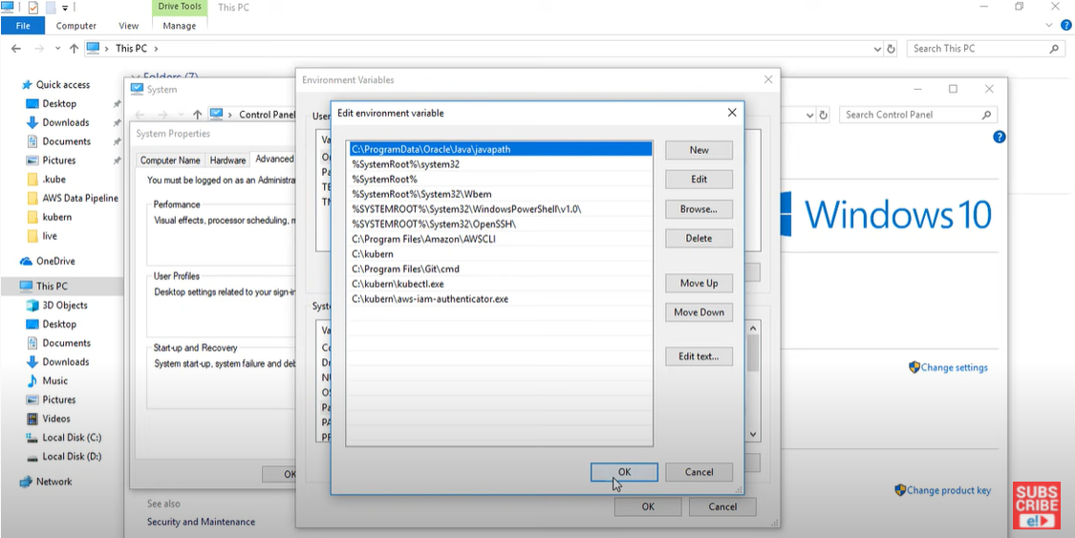

It's a tool for using AWS IAM credentials to authenticate a Kubernetes cluster. Go to documentation and download aws-iam-authenticator and store the exe file.

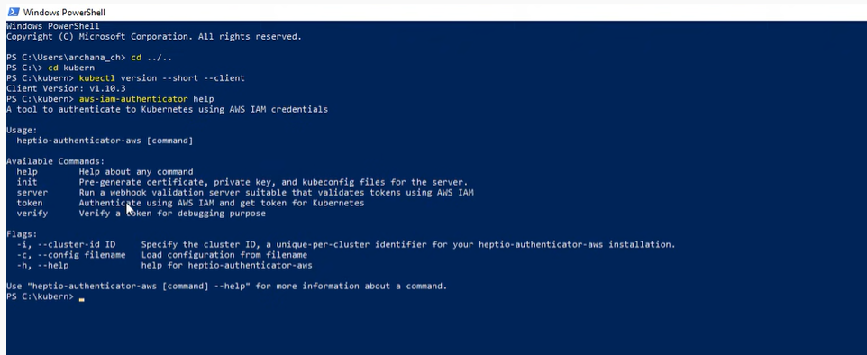

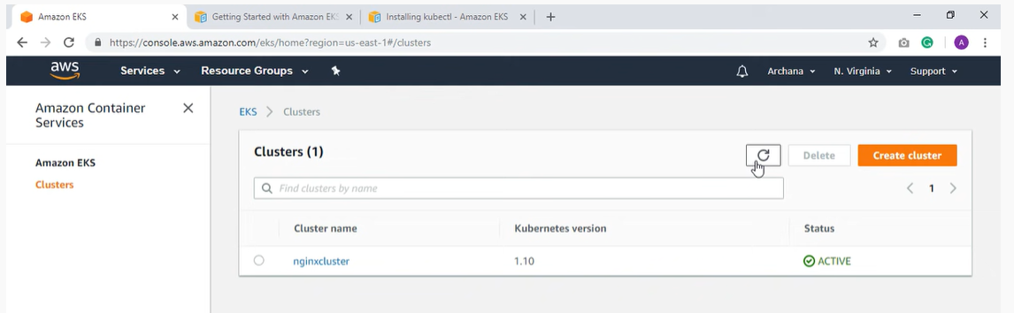

You also need to install aws cli.

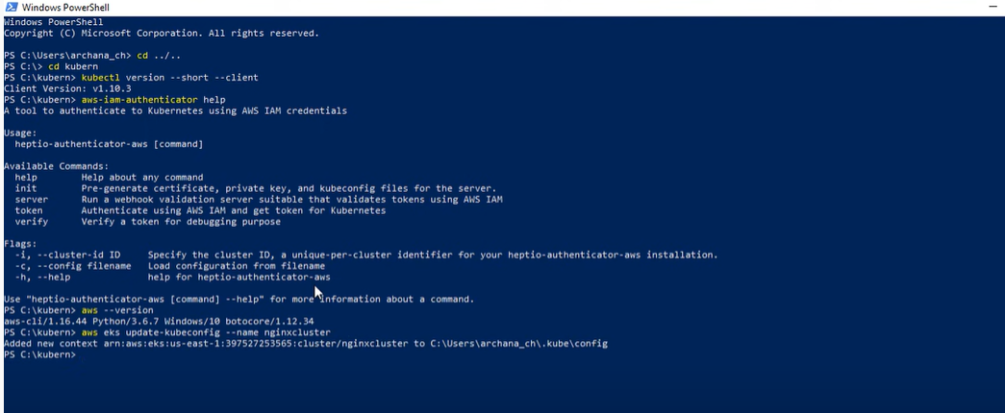

use aws eks update-kubeconfig –name (cluster name). This will also create a config file.

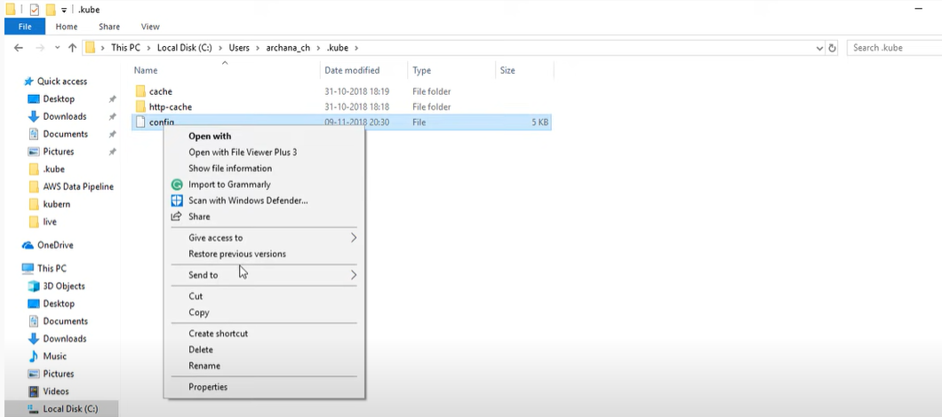

Now we need to create worker nodes which are EC2 instances which are resources that we use on AWS cloud. So, we need to use cloud formation template to create worker nodes.

Go to create a stack and from the documentation use the template url. From this template we are going to create worker nodes. Give stack name, and provide your cluster name.

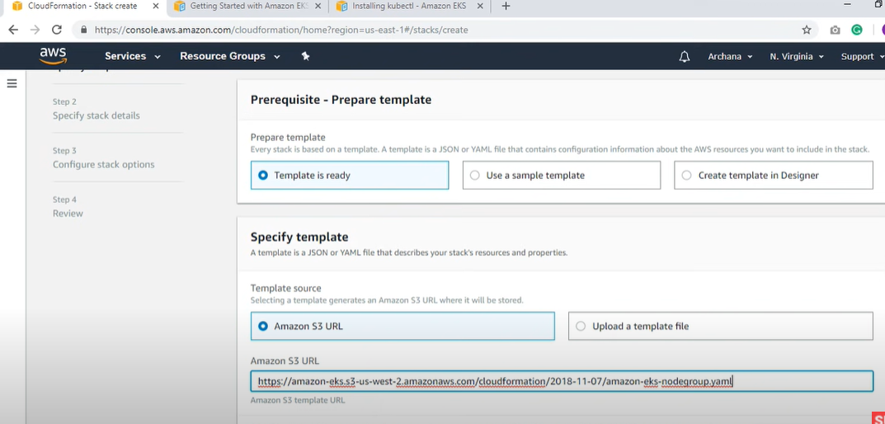

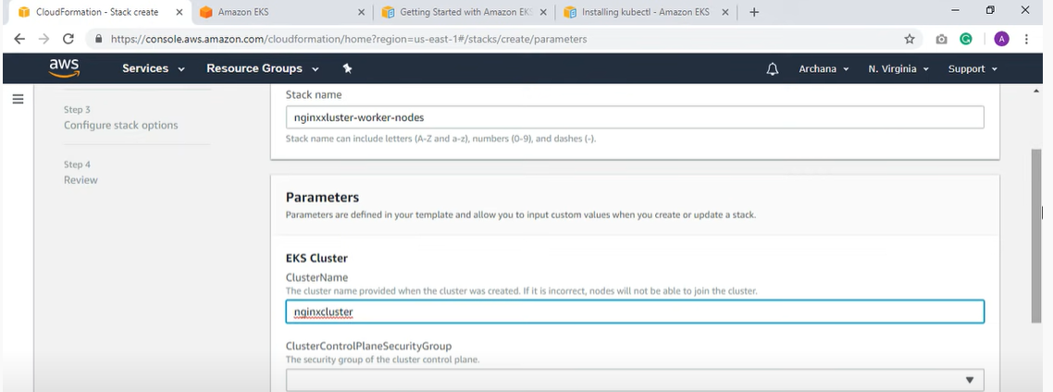

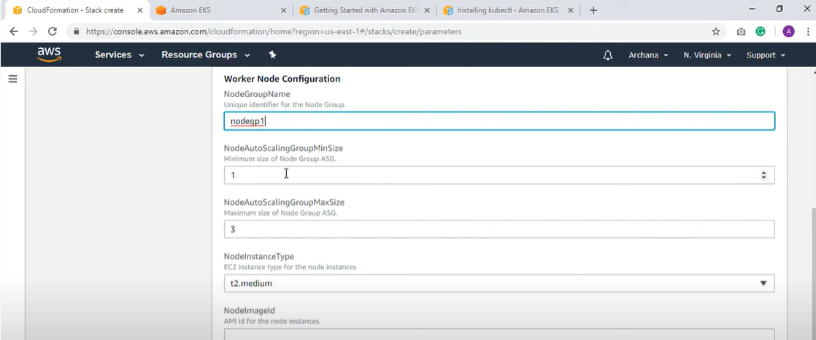

Here 1 is the minimum and 3 is the maximum number of instances for worker nodes.

As this is an EC2 instance you need to provide an amazon machine image. You can use this from documentation, based on the region you can choose the value.

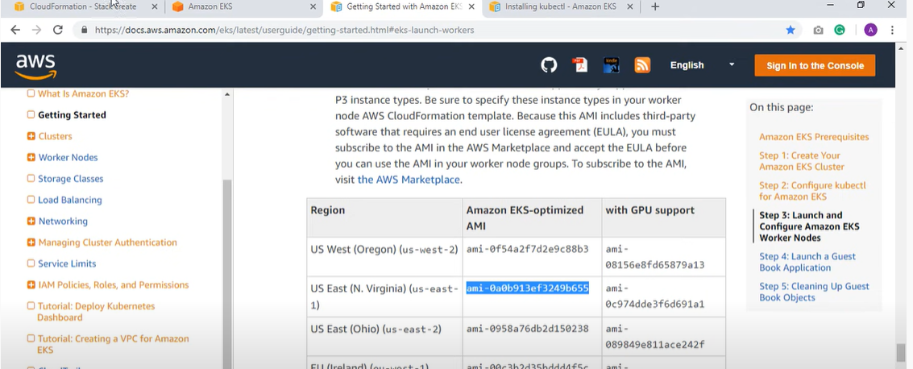

You also need to provide keyname. For this go to EC2 and you have keypairs option, you have to create keypair

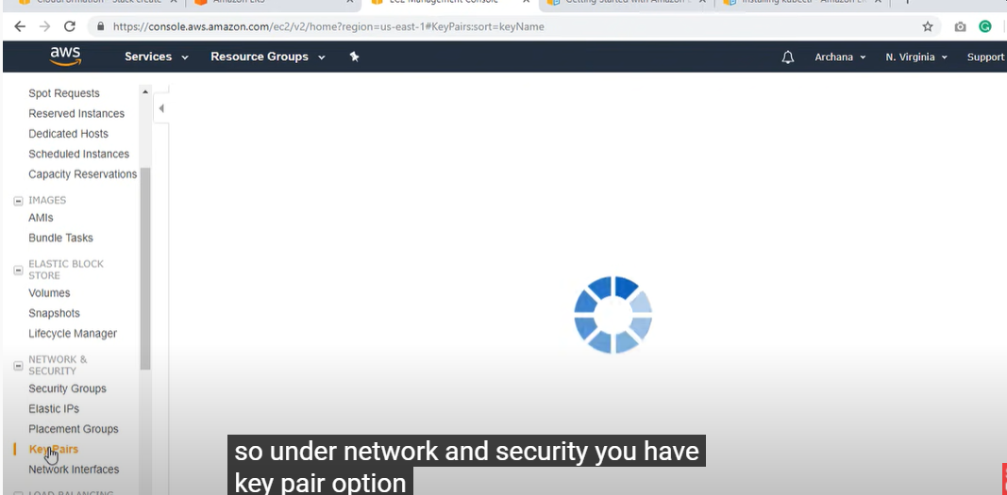

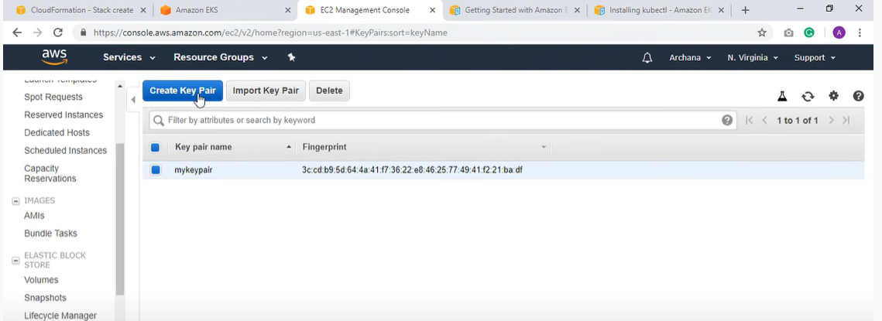

and you assign keypair like below

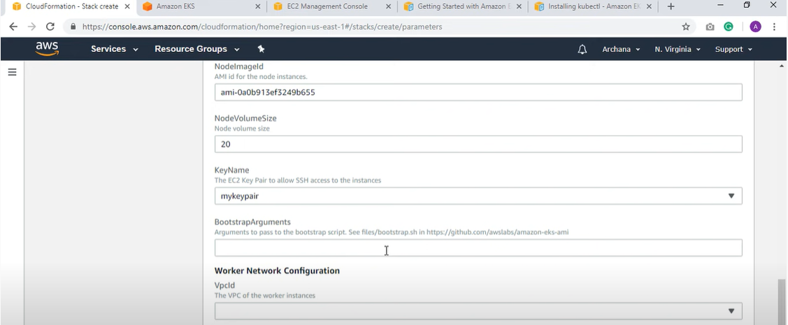

select vpc id and subnets and click create stack.

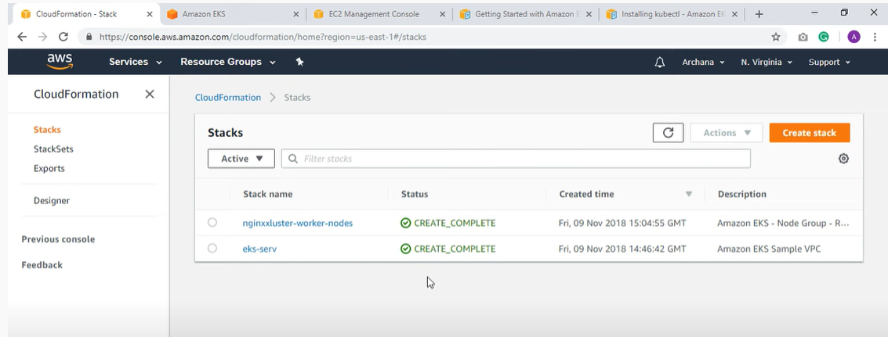

Now we need to connect the worker nodes with the cluster and for this we need to create ConfigMap.

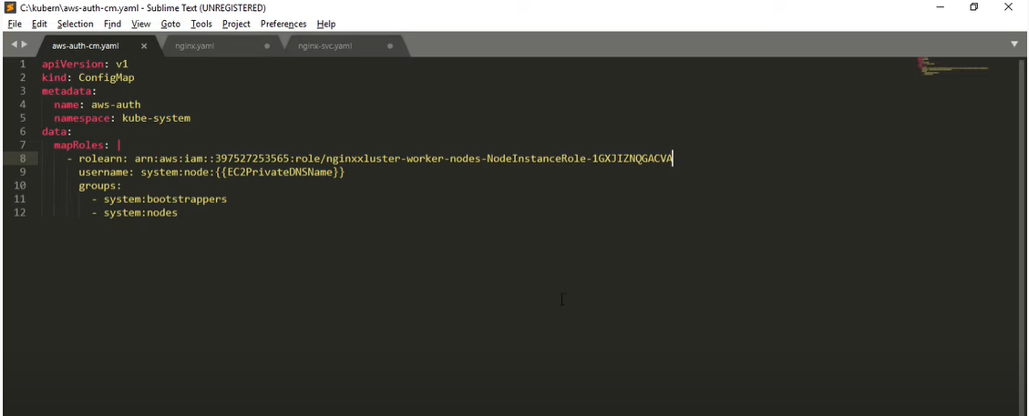

here rolearn value you can find from below

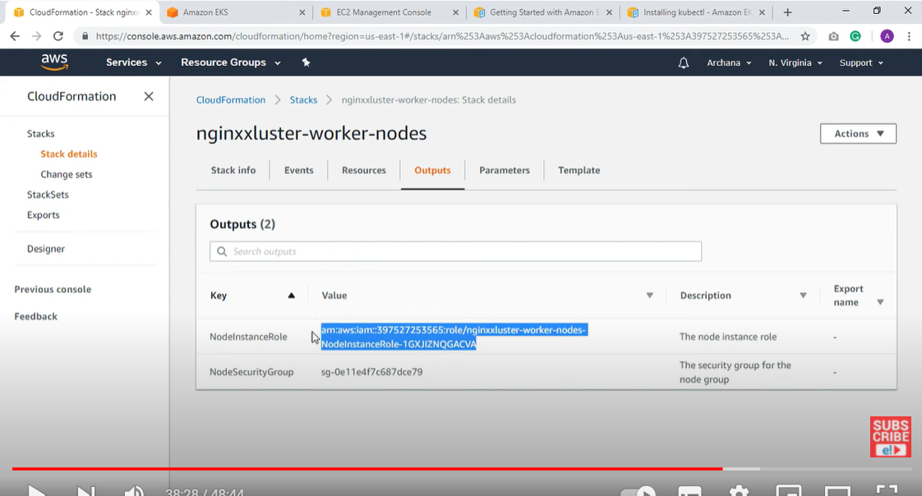

Now you need to apply configmap

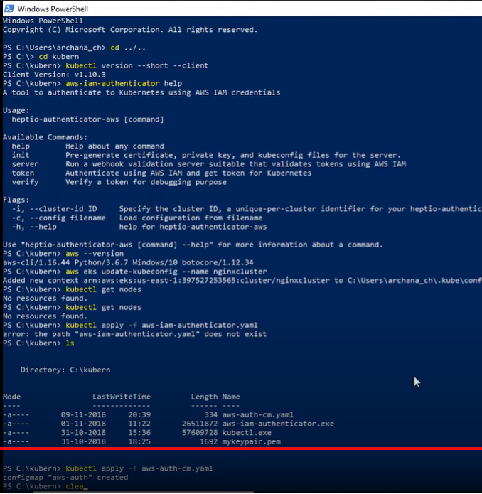

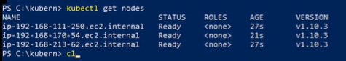

Now we have to launch application into this cluster

For this we need to use two files

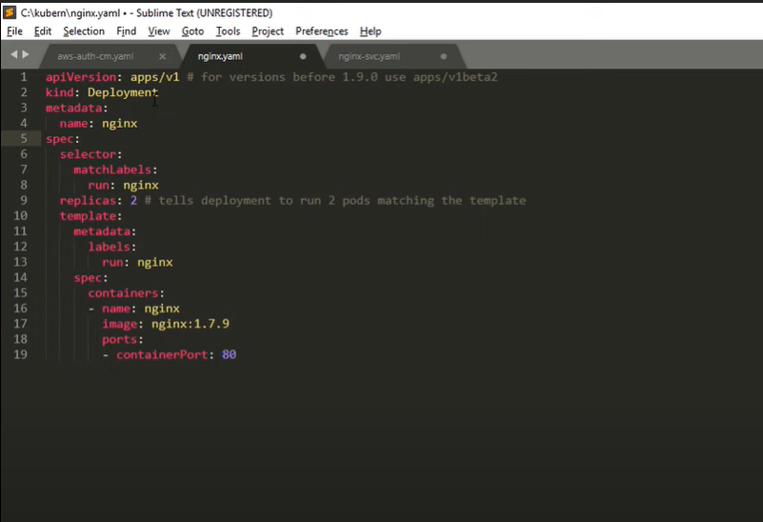

Using the deployment file we can launch application into kubernetes.

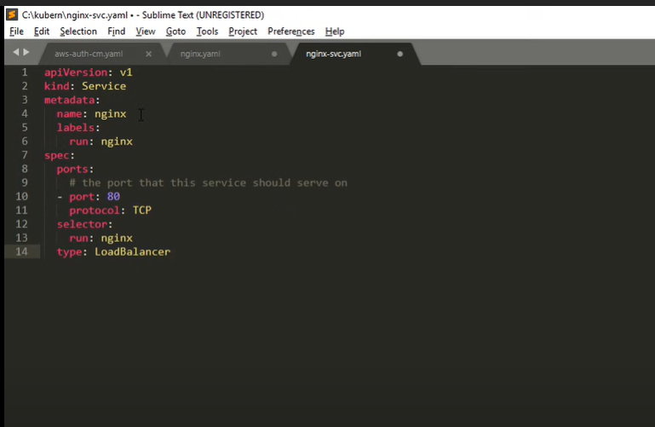

Service defines a logical set of pods running somewhere in your cluster.

Run below command

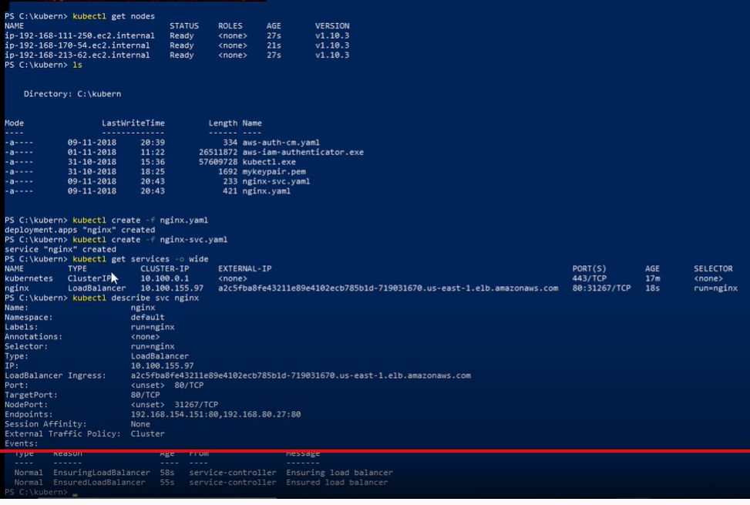

Pods are nothing but a group of containers, kubernetes runs containers on EC2 instances and it includes containers and specifications for how they should run and network and storage details. So, pod basically contains all that information.

Launch application

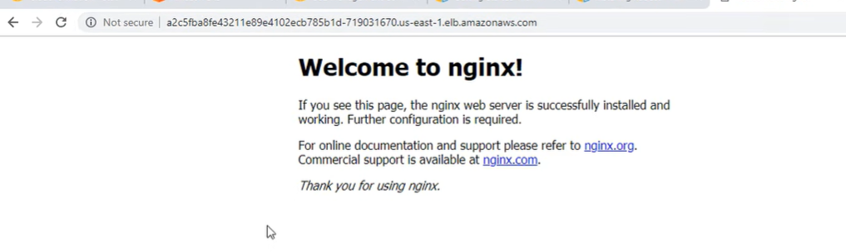

AWS EKS Architecture

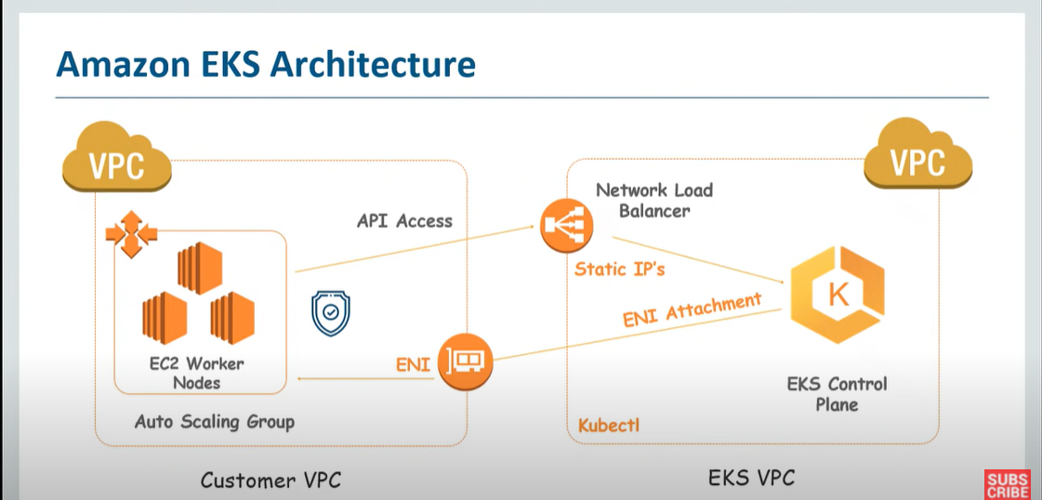

EKS service runs control plane across multiple availability zones and we have worker nodes running on customer vpc. Now we need to configure worker nodes to connect with EKS cluster and for that we need some network changes like we need to ingest ENI (Elastic network interface) which is a component of VPC and managed by EKS control plane. So, when EKS cluster wants to interact with EC2 nodes/worker nodes/applications running on worker nodes then it will use ENI to do so. Similarly, if your worker nodes want to interact with clusters then we will be using Network Load Balancer.

**AWS CloudPipeLine**

**Continuous Delivery for Java Spring Boot applications AWS CodePipeline**

1. Getting started with AWS CodePipeline and AWS CodeBuild

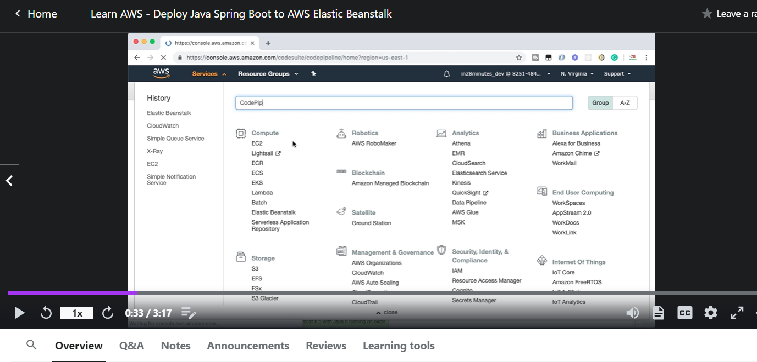

Uptil now, we were manually deploying code in AWS elastic BeanStalk.

Now think of a possibility that we commit code in github and it gets deployed in AWS elastic BeanStalk automatically. This is possible with the help of CodePipeline (release software using continuous delivery).

Continuous Integration -> as soon as we commit code in github repository, we will build and make sure that all test cases are running successfully. All the build steps are successfully executed.

Continuous Delivery -> one step further from continuous integration. Not only build, also deploy it in an environment. (commit code in repository and it is build and already deployed in an environment)

CodePipeline is an AWS service to easily configure that kind of pipeline. (start with a github repo, build and deploy). Let’s create a pipeline in the subsequent steps.

Code Pipeline -> Commit, build, deploy

Now create a new pipeline. Go in Aws management console -> developer tools -> CodePipeline -> create pipeline

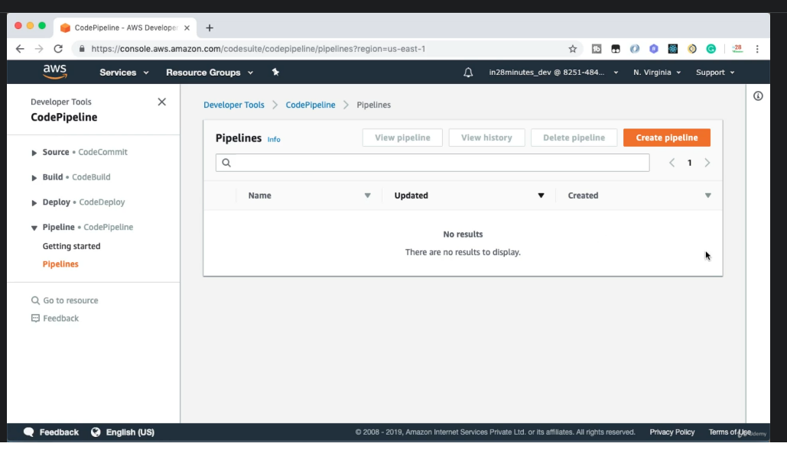

1. Choose pipeline settings.

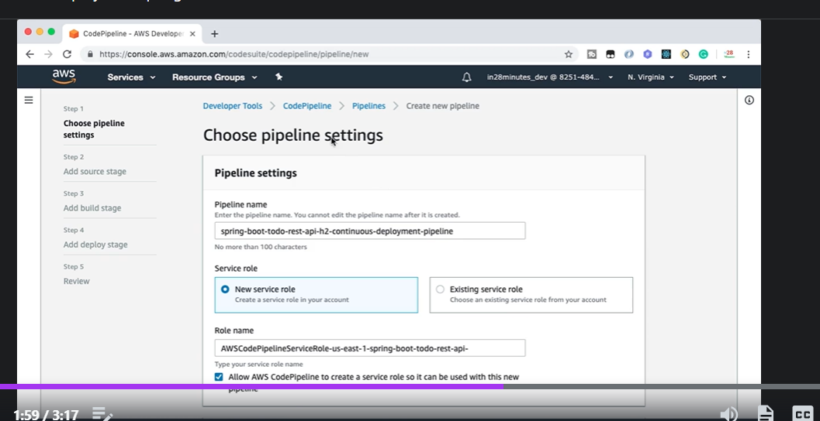

1. Add Source storage. (from where to pick code)

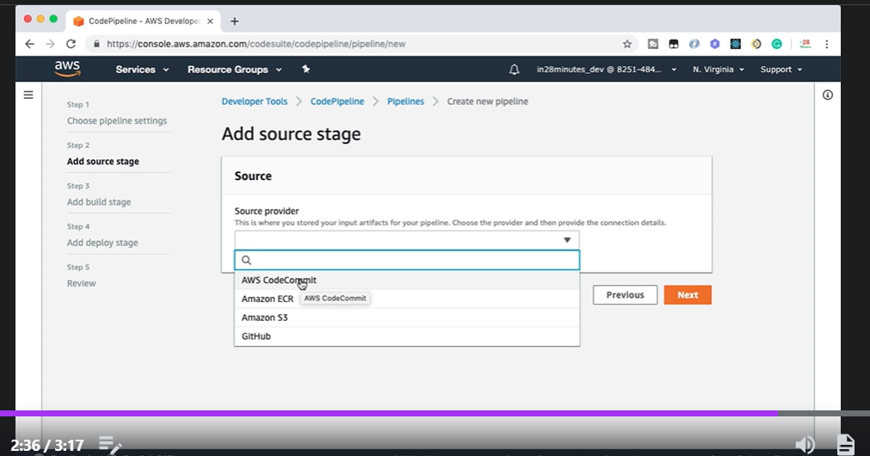

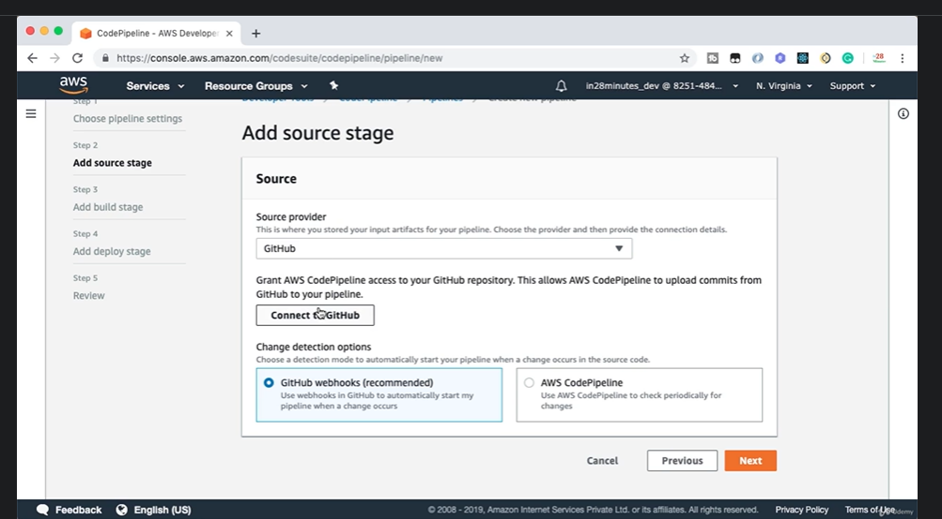

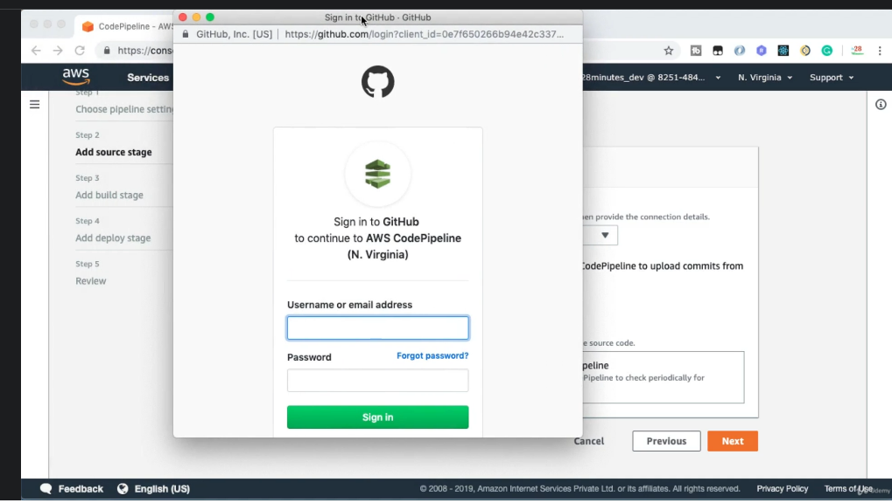

CodeCommit (github of AWS)

CodeBuild

CodeDeploy

**Step 02** -> Creating github repo and commit spring boot java project

Step 03 -> Configuring AWS CodeBuild and AWS CodePipeline

Connect with github account -> select repository , select branch

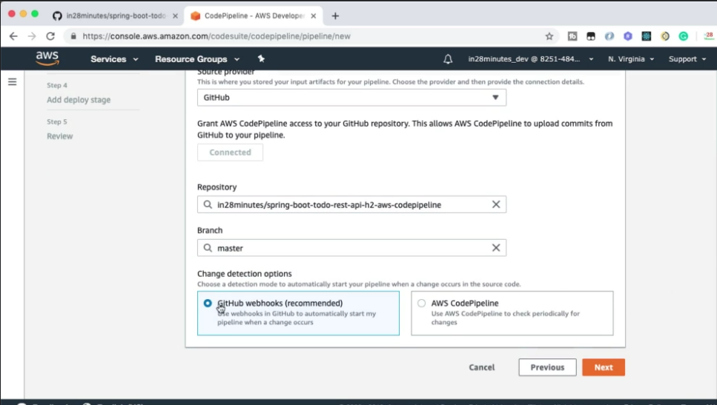

1. Add build stage

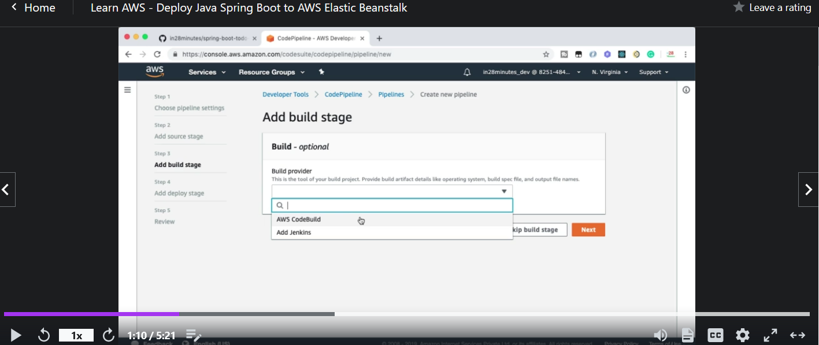

AWS CodeBuild -> another service provide by AWS to build the code (similar to Jenkins, Jenkins runs the build)

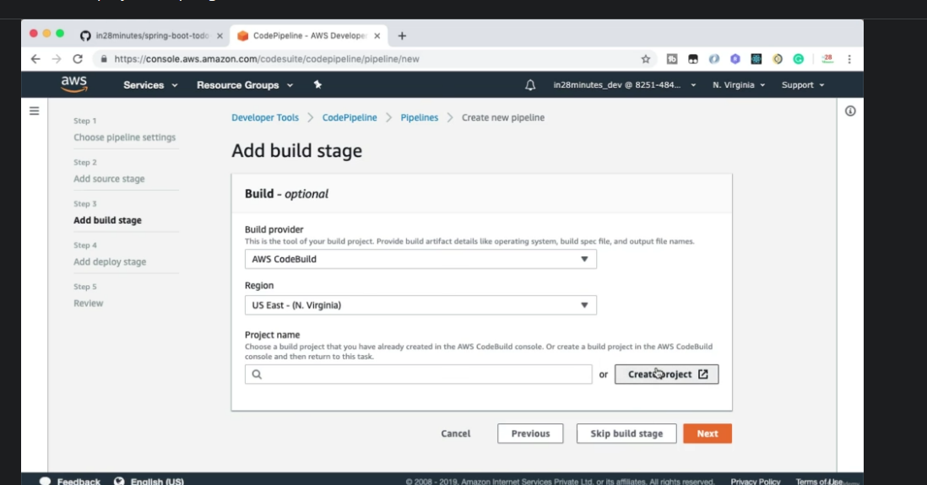

Click on create project ->a pop up will open -> configure a new project ->

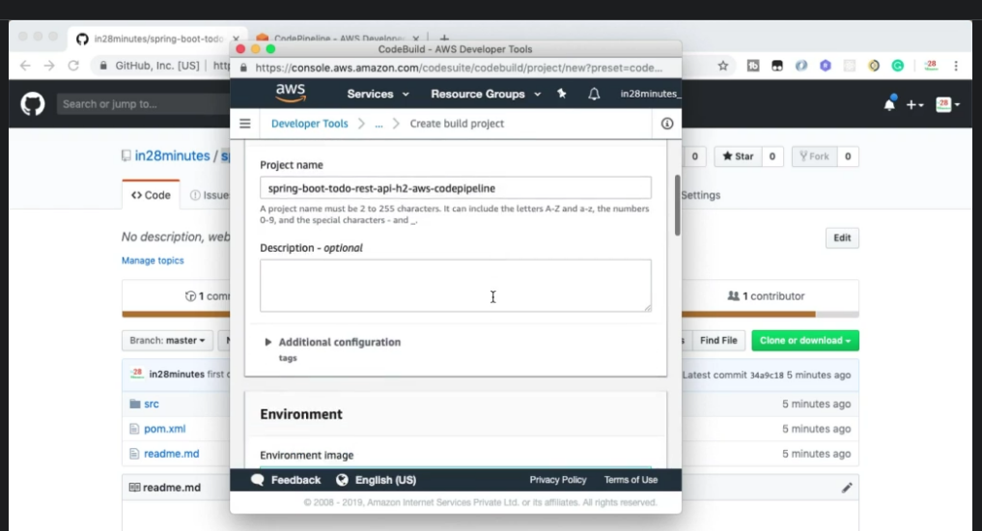

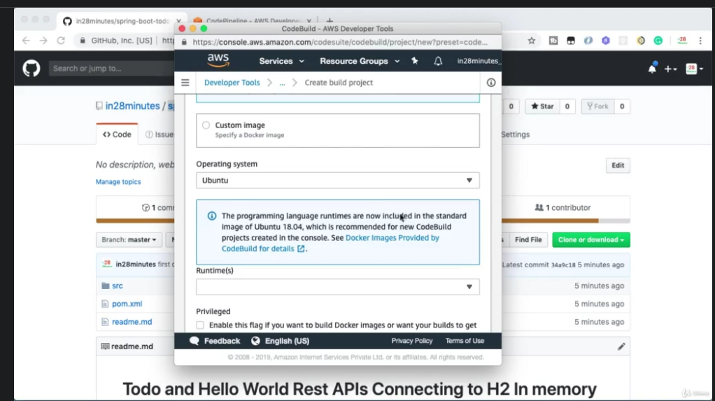

Select image -> (version 2.0)

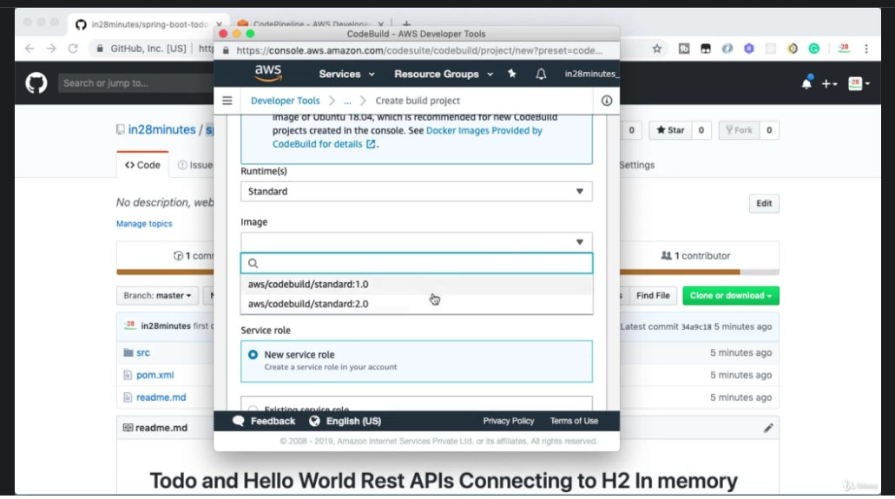

Build Specification -> use a yaml file (specify all commands while build)

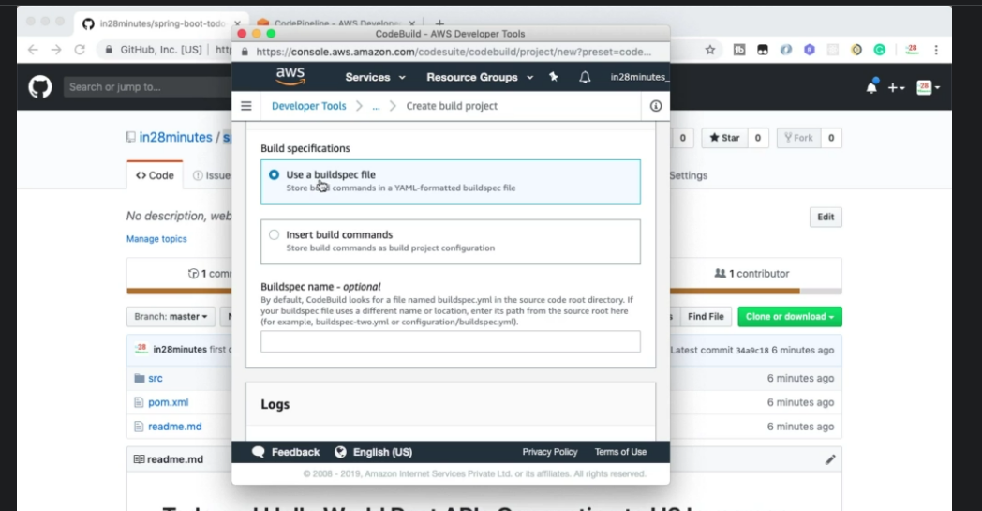

1. Add build stage

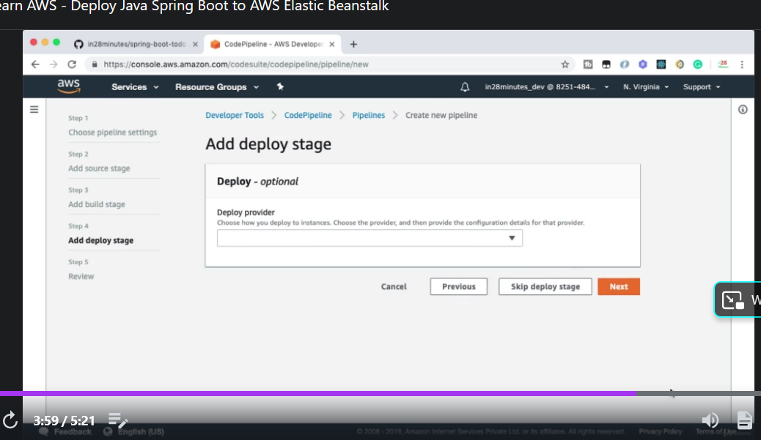

Deploy code in AWS elastic beanstalk.

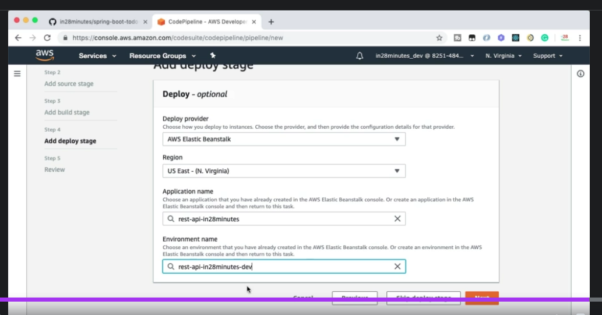

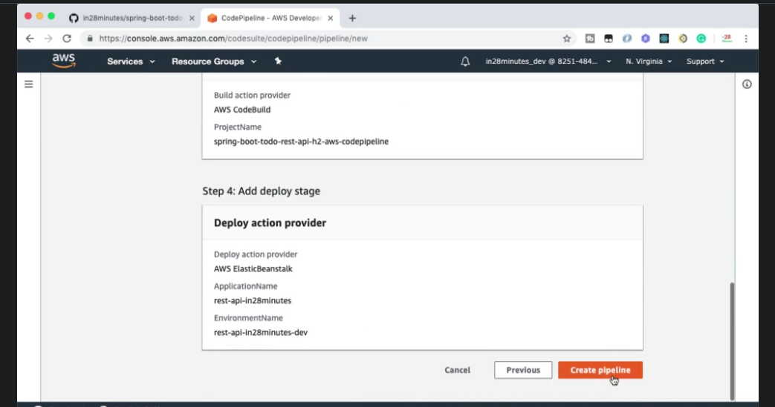

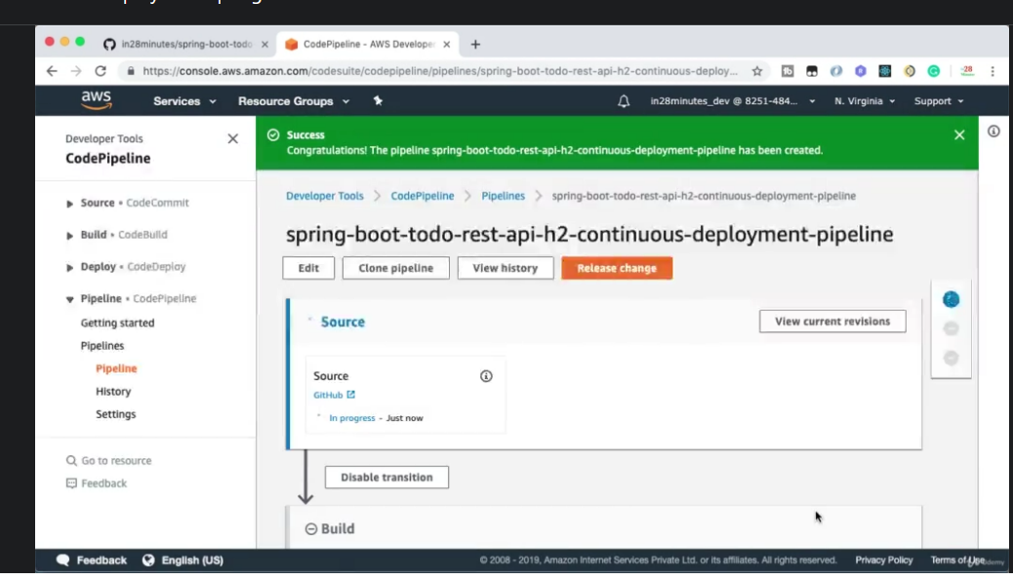

Step 04 -> Creating AWS CodeBuild build specification

Now pipeline is created. The source is successfully uploaded. But the build has failed. Because we have not specified the yaml file of build. How to write a yaml file for build specifications ->

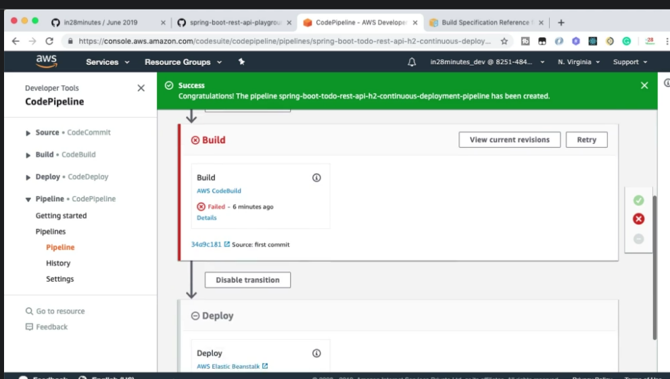

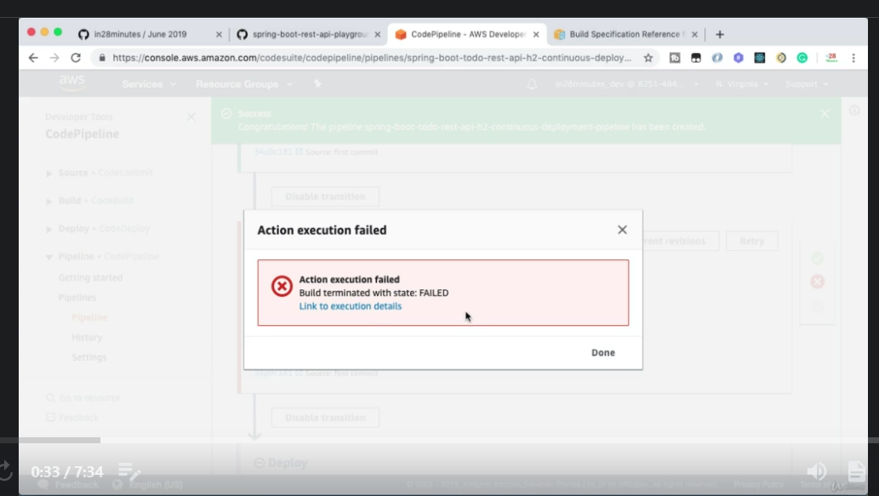

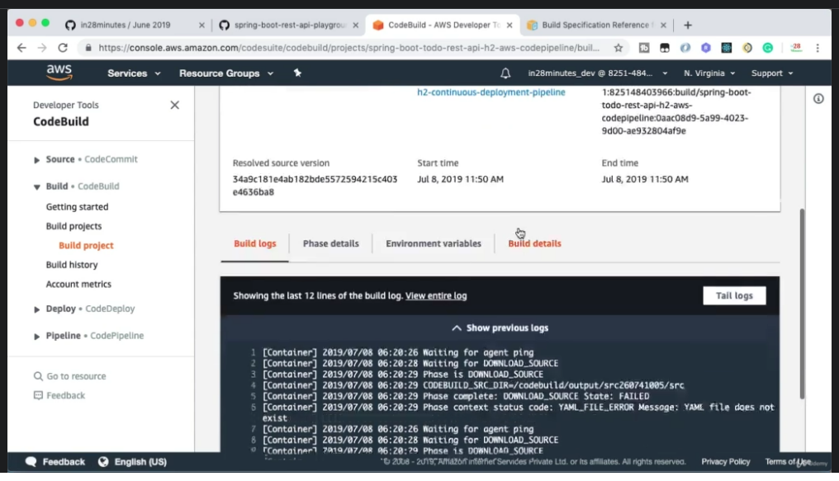

The above message dispalys yaml file does not exist.

Import springboot project from github in your IDE.

Create a yaml file for build in spring boot project. Update its artifact id correctly.

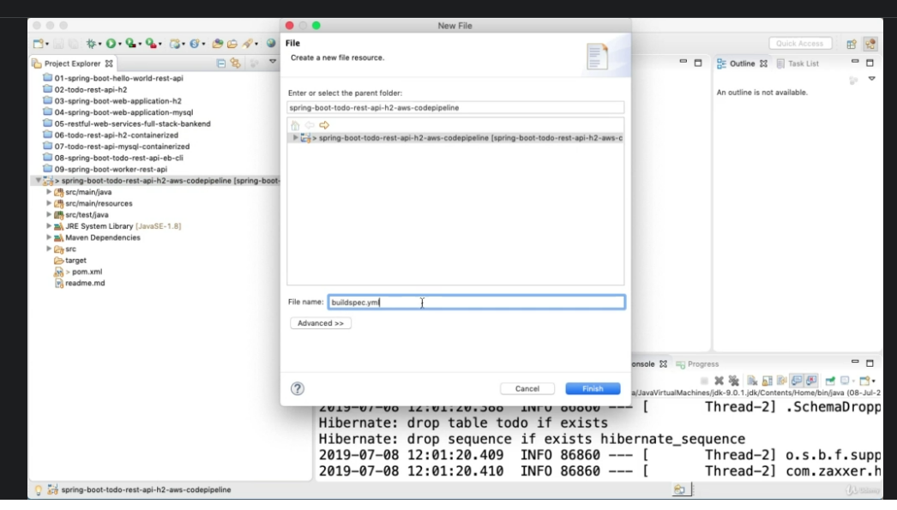

Go in AWS documentation and copy syntax of yaml file for build and paste it in newly created yaml file in IDE.

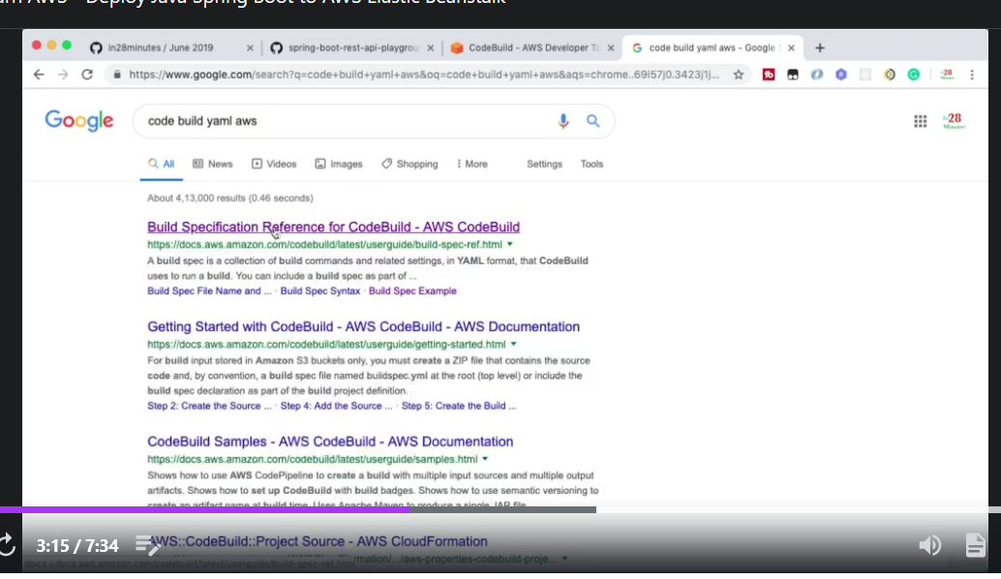

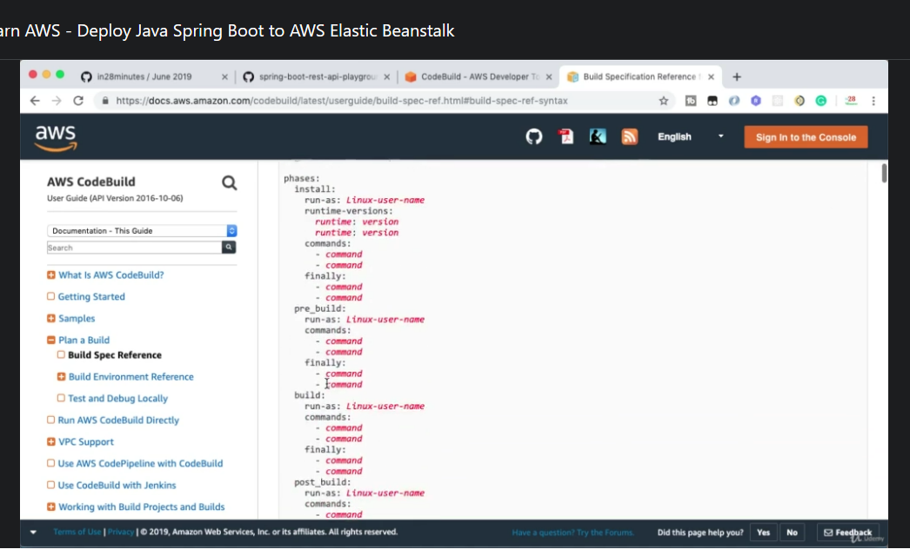

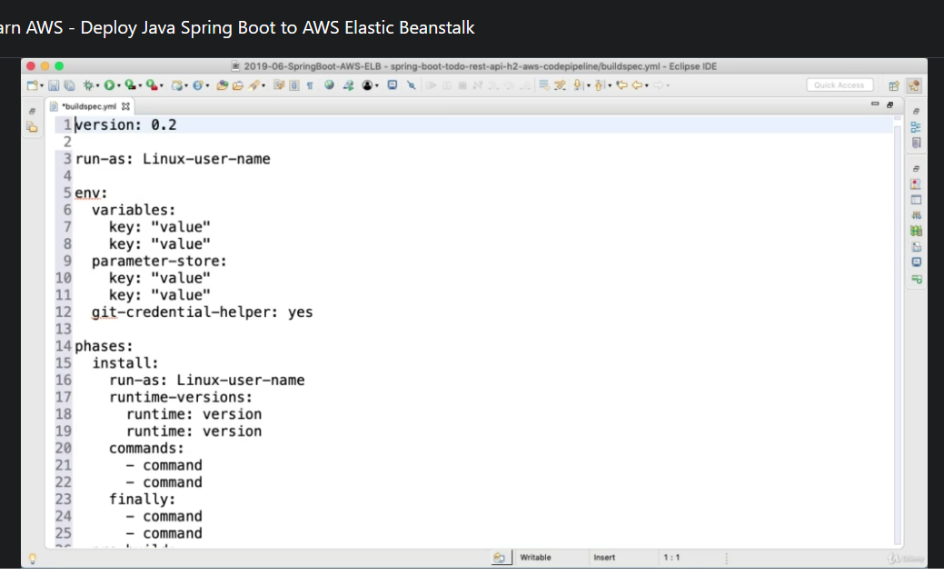

Modify yaml as follows:

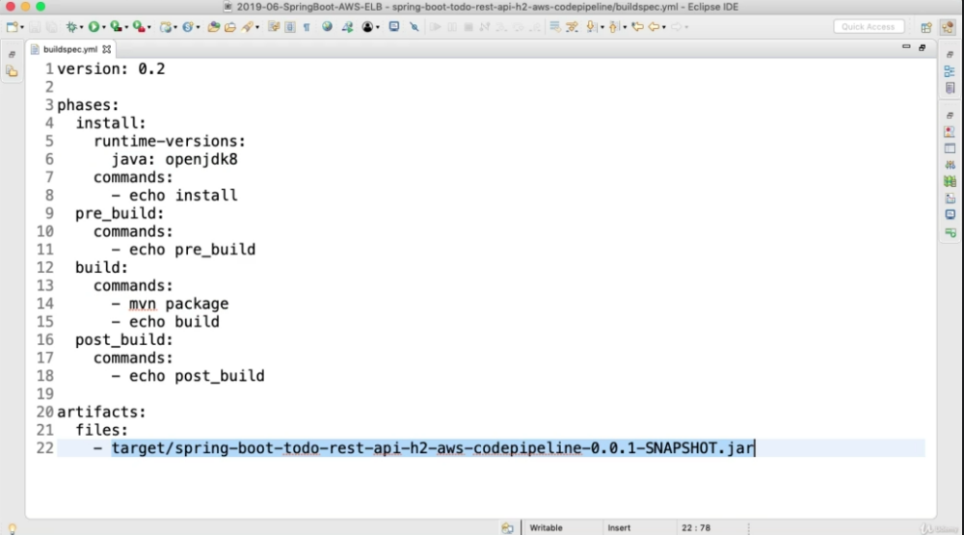

Step 05 -> Testing Continuous deployment with AWS CodePipeline

Now commit this yaml file in github.

As soon as we commit it , code pipeline gets refreshed and pick ups all new commits.

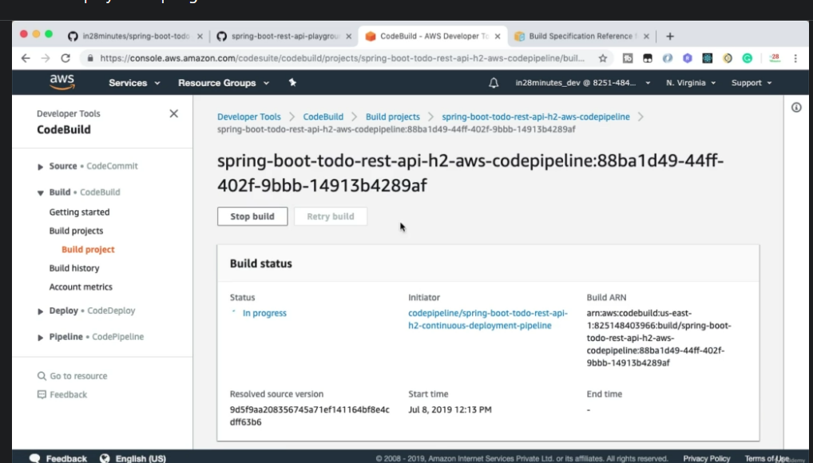

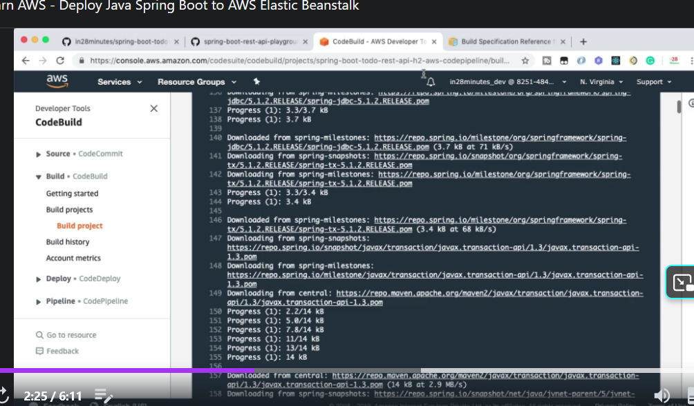

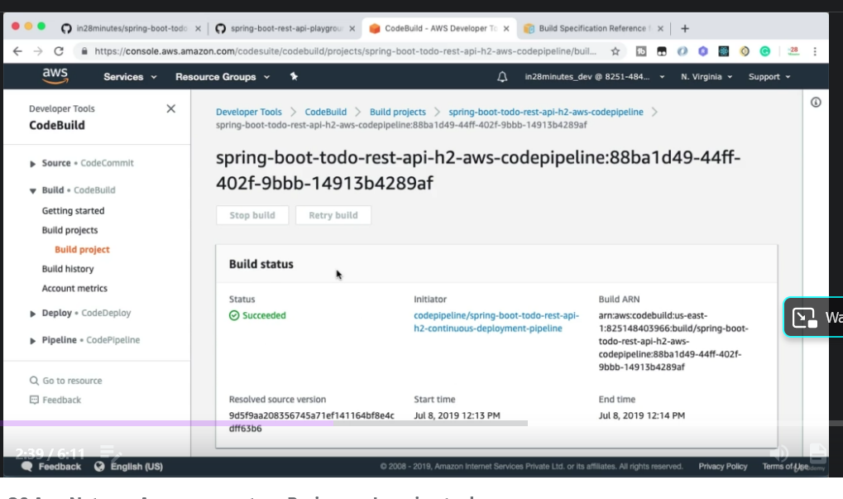

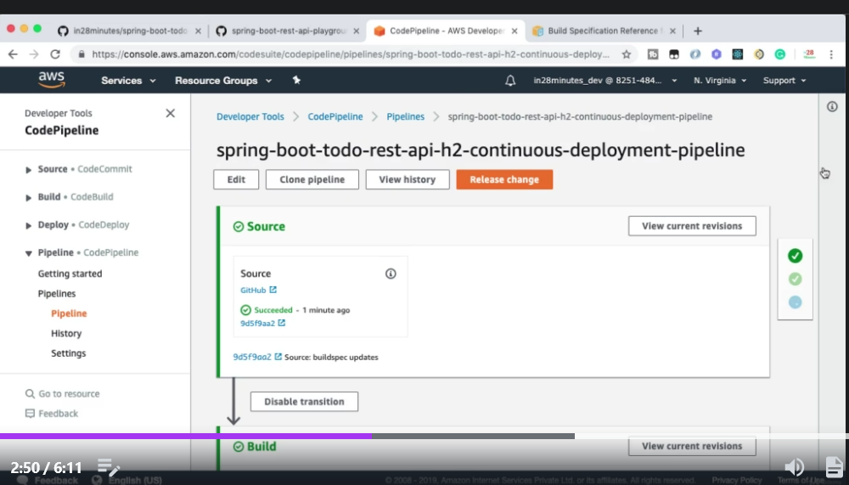

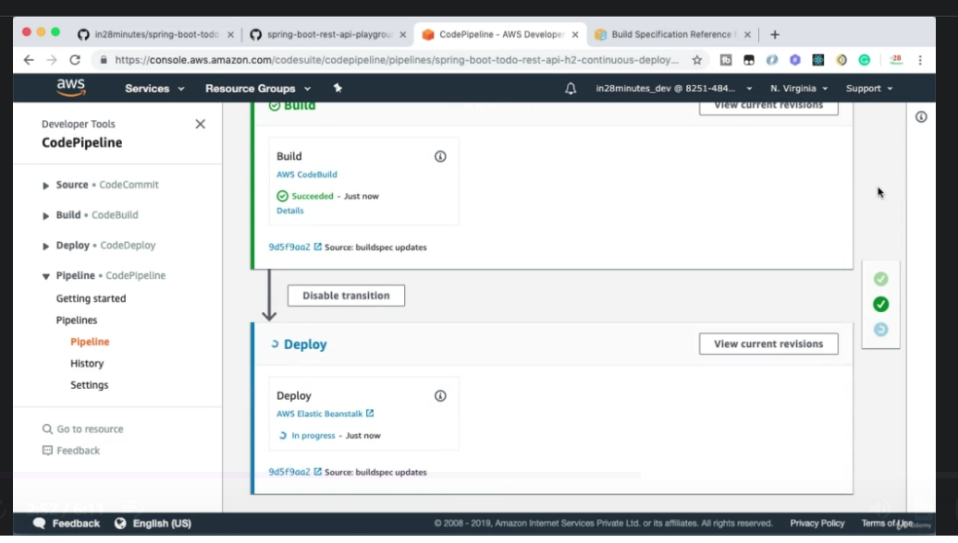

The build is successful now. It is deployed into elastic beanstalk. Click on AWS Elastic Beanstalk under deploy. You will see following screen.

